SolutionManifesto.com ISBN: 9798394156342
HardCover 9798394163302, Version 1.0.8 is 9798392441563
GodsConstitution.com Version 1.2.5 - 2026 Feb 13
Procreator Author: Keith Brent Duncan 1-19580815-1 (+100%)
Atlanta Georgia USA +1 770-377-2106 info@FortuneONE.org
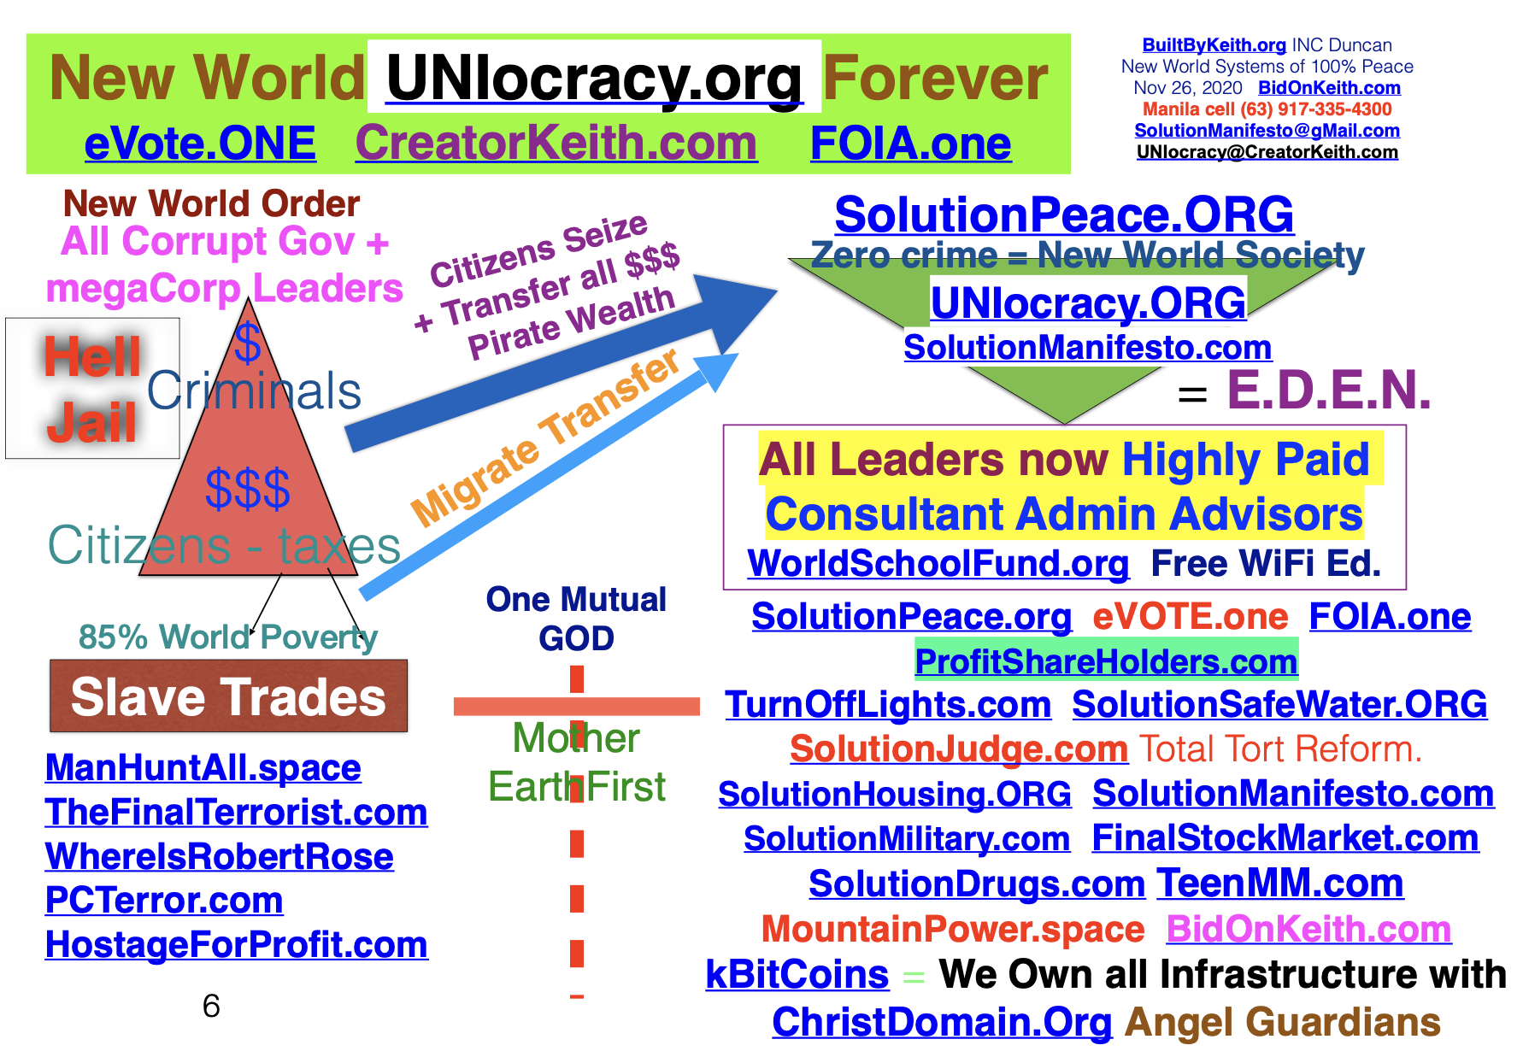
(C)(r)(TM) Patents held by FortuneOne.org CreatorKeith.com Who Do You Know who knows My Father GOD?
UNIocracy.org Diagram of New World Sovereign No crime Universal Society
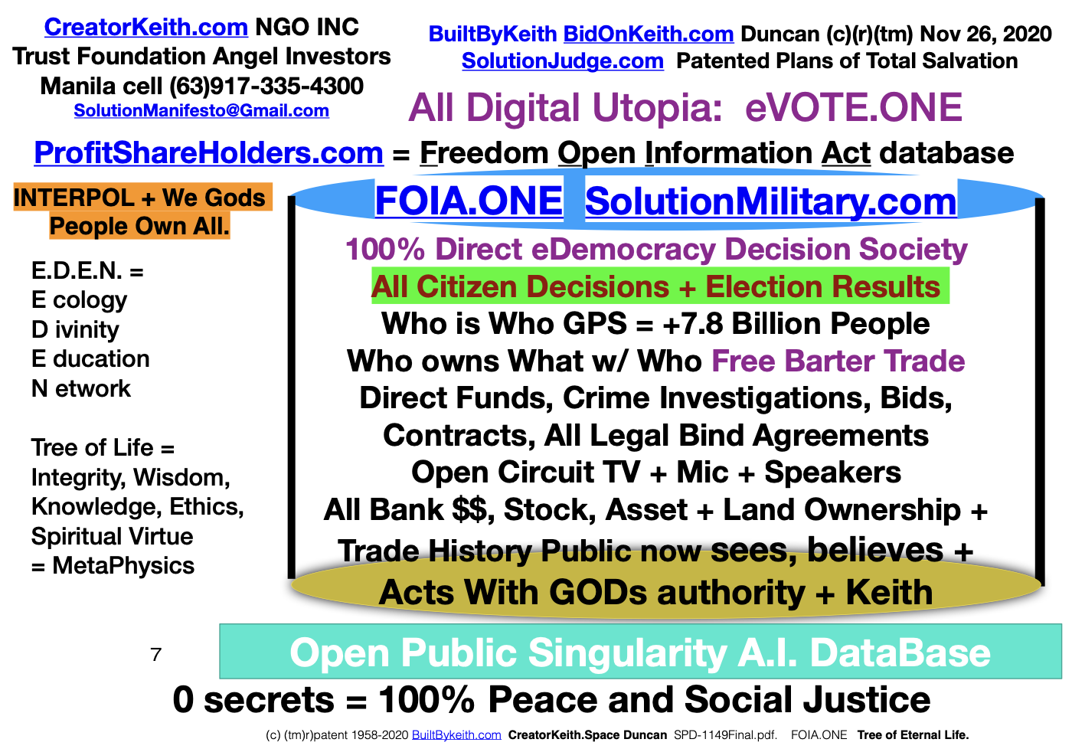
EVOTE.one Unifies All Mankind for ever.
FOIA.ONE Universal Stabilizing OPEN Public shared World Database
- We vote on Who is the new NEXT Project Manager using FOIA.ONE
- We vote OUT any person who refuses to complete #3 projects. KeithsRulesOfOrder.com using FiveSteps.LIFE agreements.
3. We vote on the NEXT best project by our majority. No 51% over-ride required.
4. We vote UP, DOWN, or same the cash paid to each leader. No more Stock Options, Exec Perks again. No secret deals, Political Parties, or any violations of below.
5. Anyone can run for any office in any nation with no birthright restrictions.
6. Proxy assignment of decisions by any individual.
7. Public can eVOTE and assume title ownership to any infrastructure, land, energy, etc or equal public built structure even if the entire corporation is privately owned.
8. This is retroactive social and peace justice against ANYONE who previously violated our rights to be free will citizens based on Article 2 and Article 3 below.

Table Of Contents - GodsConstitution.org

Table Of Contents - GodsConstitution.org 3
DueProcessLaw.org Replaces all known man made laws. 4
Declaration of World Sovereign Free Will Independence. 4
Article 1. eVote.one FOIA.one 6
Article 2. Original Mutual Creator Commandments. 9
Article 3. Human=God International Bill of Rights. 11
Article 4. Sign Binding Peace Treaty Agreements of UNIocracy.org through FOIA.one WTFone.org 17
KeithsRulesOfOrder.com 19
TeamMoneyMachine.org Excerpt 23
Revision TMM28. 2023 March 21 CreatorKeith.com Duncan +1 770-377-2106 25
PeaceSUMMIT2020.com Town Hall Forums 29
WhoIs List of GOD + Keiths World Saving Solutions 30
CEO CreatorKeith.com (c)(r)(tm)Patent WorldPTO.com 1958-2023 41
The Meta Physics . Foundation = TheMetaPhysics.org 41
SolutionMed.org 43
Resume for Keith Brent Duncan. 44
SolutionEnergy.us EcologyMINING.org was LaserTunnel.com CEO founders of new world UNIocracy.org publishers and Angel Guardian VC philanthropists. 50
AMBERprotect.org ChildProtectCoalition.com 53
BBK20160826-13PlaguesRevelations-SolutionManifesto-393 57

DueProcessLaw.org Replaces all known man made laws.

Any person who accuses another of a violation/crime, must show all evidence with 10 day speedy trial Gods law. Accused has all self evident rights to demand full exposure of the accused life, assets, and evidence. Countersuits of libel and slander now enforce Article 3 of GodsConstitution below.

Perfected as Gods Last Testament is our mutual shared final Covenant achieves total world peace for +8 billion Will of WE GODs People forever. (c)(r)(tm) Patent WorldPTO.com FortuneONE.org +1 770-377-2106. Universal use of standard stabilizing direct eDemocracy EVOTE.ONE FOIA.ONE fast path eliminates all violators of OUR basic human rights forever.

ReInvestALL.com TeenMM.com gifted simple methods generated by 5Steps.life procreates our new world UTOPIA free of all criminal enterprise networks using GOD + Keiths state of art patent engineering technology showcased top of UNIocracy.org

Declaration of World Sovereign Free Will Independence.

We GODs People hereby self evidence declare our freedom liberation from any person who violates the following new world legally binding Constitutional law replacement system authored by GOD, Keith Brent Duncan, and our fellow GOD focused integrity ethical trustworthy peers worldwide. This to be RATIFIED immediately by YOU, now +8.27 Billion WE Gods Children !

Article 1 Evote.one Direct eDemocracy forever.
Article 2 Gods 11 Enforced Commandments.
Article 3 Human God Bill of Rights forever.
Article 4 Trade Agreements between you.

By God sent most humble Keith Brent Duncan(c)(tm)(r)Patent holder of ALL Gods self saving technology. Combine with SolutionMilitary.com Citizens Arrest of anyone who are violators. All infrastructure of all levels of society are now communally shared by everyone. Anyone who objects to this 3 Part Commandment Constitution is required by all others to provide a better = Best always GODs SolutionPEACE.org 5steps.life

Our New Universal Stabilize Constitution by FiveSteps.life was 5Steps.life of EVOTE.ONE and 4 Sections for all humanity. These are the center stone foundational principals of our UNIocracy.org New World Age replacement Society. We The People empowers humanity to decide our own community reality and 100% positive future destiny. Below empowers +8 Billion GODs children to pass judgment on each other and NEXT best project for all.

VERSION 1195-VeryLast-2023May09-SolutionManifesto-GodsConstitution-FortuneONE-v106.PDF is updated today on amazon.com to be share GIFTED 8 BILLION WE GODS PEOPLE forever to finally stabilize humanity as ONLY PEACEMAKERS forever using all the perfected solutions we personally generated using GODs original primal problem solving mind mapping 5STEPS.life

Article 1. eVote.one FOIA.one
eVote.one Electronic voting is our real time instant proxy 100% decision based society store and forward in OPEN PUBLIC shared database of FOIA.ONE. Everyone self identifies by IID DOB.

- All leaders are electronically voted IN by one general election. All vote total counts are PUBLIC viewable directly over the Internet. Votes are marked private or PUBLIC. Tallies all shown to world with method of write once, then read-only public counts seen by all. Each vote is tied to your photo/video stored for any retrieval in the single new world society open public database FOIA.ONE. Over time, any leader can be electronically replaced once the rest of UNIocracy.org system universally self stabilizes each of you +8,25 Billion.
- Any Government or Corporate leader is voted OUT by majority who violates law, suspected of fraud or personal profiteering OUTSIDE their #4 pay or refusals to complete #3 below. Each are replaced by succession runner-ups, NEVER by appointments or re-election process controlled by the old Ruling Elite or old named party control. This is easy Retroactive punishment + seizure of assets for any previous violation or crime by any individual as the ultimate deterrent. Our young people now become our new world leaders free of corruption + crime using WorldSchoolFund.org
3. Direct eDemocracy Post Election, All leaders electronically TOLD what to do next by evote. ReInvestALL.com is ProfitShareHolders.com empowers share holders and employees to control their assets. All Direct Funding builds NEXT best project so NO ONE can divert use of our assets. No more appointed officials who conspire with others to violate laws. SolutionJudge.com Total Tort Reform eliminates all corrupt individuals including Liar=Lawyers + all other terrorists. Enforcement by SolutionMiltary
4. All leaders consultant pay is electronically voted UP, same, or DOWN by the majority will of our people. All leaders are now highly paid consultant Administrators ONLY, with no direct access to any taxes or ability to profiteer by controlling any of our assets or laws. This includes all corporate executives below. All must show their income / expenses / ownership of all assets with FOIA.ONE. Each deserve to be protected AFTER they fearlessly serve + protect our people by tracked performance of #3.
5. Anyone can run for any office in any nation if IID returns +90 Integrity ranked from SQL query on FOIA.ONE WTFone.org world trade database.
All of these 8 By-Pass Constitutional laws are irrevocable and irrefutable baseline for all humanity. This is Enforced Integrity.
6. Proxy assignment of decisions by any individual/group. Each person has override voting privileges at any time based on IID.
7. Public can eVOTE and assume title ownership to any mall or equal public built structure even if the entire corporation is privately owned. Boycott protests is an option to eliminate the Corporate Executives who cause all mass poverty and wars.
8. This is retroactive justice against ANYONE who previously violated our rights to be free will Sovereign Barter citizens.
Our work was completed Summer 2011 = 10 years ago stating the exact same New World System ... UNIocracy.org
By simple Will of Majority of WE the eVote Free Will Sovereign People, any person or group can pass judgment on anyone else once all evidence is show in OPEN FORUM COURT of FOIA.one for everyone else to see who is linked to organized crime or Honest groups.These are the legally binding and enforced contracts between any two parties including with Political and Corporate leaders at levels. These are the only ratified legal methods to stabilize all economies by returning control and ownership of all assets back to each community.
PeaceSummit2026.com All Host Mediates book ProphetKeith.com BidOnKeith.com Duncan +1 770-377-2106 info@FortuneONE.org. Each of you, + All world leaders, Presidents + top Elite Corp Executives Commanded to attend Town Forums Monthly and use KeithsRulesOfOrder.com

1. We solve all base world problems FiveSteps.LIFE + IseeStand.org as Public Servants of We Gods People crime free utopia UNIocracy.org

2. Rapid deploy universal shared ONE open public database FOIA.one IID Who is Who. Share all evidence of who are top violators to purge.

3. Assign SolutionMilitary.com to find terrorists Open Public Investigations. All military now are only National Guard and investigators.

4. Agree to redistribute crime wealth to 3rd world nations in greatest need using Evote.One . CreatorKeith.com 1% seized and crowdfunds to +8.1 Billion Gods People. No more Wars, Stock Markets, underground criminal deals, no more violators of GODsConstitution.org ever again = eternity.

5. Agree to transfer millions of our young adults to places of greatest needs with WorldSchoolFund.Org 100% free Foreign Exchange Student Keith's Program. Use of perfected simple Common sense TeamMoneyMachine.com translated into all world dialects with ENGLISH being prime language.

6. Agree to remove all by-laws and regulations that prohibit the immediate deploy of ProfitShareHolders.com from being our new world free trade total barter society. ReInvestALL.com shows how WE GODs People now use only kbitCoins.org as financial temporary credit/debit number system.

7. Agree to eliminate all corporate corrupt criminal violators of human rights individuals using Will of Free Citizens use of Gods SolutionJudge.com by EVOTE.ONE. SolutionManifesto.com perfected by GOD + KeithBrentDuncan.org eliminates all man made laws including LLPs and secret parties.

8. Agree to universal use of one FOIA.one IID and eliminate purge DOJ DOD Corporate Executives who violate laws SolutionLawEnforcement.com + SolutionManifesto.com

9. Protect the lives + Assets of SaintKeith.com + those of highest IQ merit today. 2025 Jan 28 to end of GODs eternity. GodsCrusade.org complete.All Presidential, Leaders, Corporate Executives Work for GODS people. Reset from Sept 2011. DuncanClaim.org WhereIsRobertRose.com

Article 2. Original Mutual Creator Commandments.

11 Universal God Commandments in current international dialogue.
1. You will not worship false idols. We have one mutual Creator system. One may worship any belief system as long as no ones rights are violated and no harm is caused to self or others. FOIA.ONE is used to decide who has integrity.
2. Honor the rights of all others first, thereby insuring that your rights and others are not violated and/or harmed.
3. You will not murder. Optional Death Penalty is by eVote.one Will of Open Public Majority + SolutionMilitary.com.
4. You will not falsely testify against another. FOIA.ONE is World Library of Congress Tree of Knowledge + Wisdom
5. You will not steal. Restitution to victim is +3 times the value of the property and harm caused by criminal and their associated crime networks.
6, You will not commit adultery. Divorce is permitted by eVote.one Will of Majority of those affected.
7. You will not play games of lottery and betting as these are sins of predatory greed and crime networks. No exceptions ever again.
8. You will never abuse drugs, alcohol, or mind altering substances or action behaviors that harm self or others.
9. Honor thy children, elderly, disabled, mother, father and all others by holding self and others 100% accountable.
10. Love and Care for each other by keeping no secrets and benefiting all others first. 1 Cor 13:13, John 10:30.π
11. Act with the Authority of Fearless People to Protect the Rights of all others first before thinking about protecting ones own rights and benefits. This is the original Commandments of "Love Your Enemies' 2. Love your neighbor MORE than oneself. Apostle most humble servant of God, Keith brent duncan = worlds first Freeman Sovereign Ambassador Emissary. Last update Nov 26, 2022 of last historical legacy heritage world broadcasts.
SolutionManifesto.com is SolutionJudge.com that also UNIFIES ALL HUMANITY Forever by Preventing Crimes in first place and immediate Punishment by commands of Majority of our eVote Promise keeper Peace maker Unified Sovereign People. Passing Judgment by open testimony is hereby legalized to eliminate the root LUCIFERS who cause all conflicts.
DIRECT eDEMOCRACY is the only unify reform solution to solve each of mankind's root greed, sin, vice, and crimes.
EVOTE.one #3 eliminates all taxes, corruption, crime, and underground networks ALL at one time.!

Article 3. Human=God International Bill of Rights.

‘HIBoR’ These are self evident, unalienable, irrevocable, and irrefutable.
These are all common sense and quickly addresses all criminal networks forever. No more cabal corrupt politicians, Gov officials or Corporate leaders. No more any underground criminal enterprises can exist once everyone exposes WHO is WHO, WHO OWNS WHAT, Who trades What with WHO.
These are the ratified second level (backup) commandments when any of the above Base Commandments are violated. USE of EVOTE.ONE is the PRIME prerequisite fore-founding legendary heritage world wide principal for all mankind of DIRECT eDEMOCRACY Decision Based New World UNIOCRACY.ORG. society.
1. Right to own property, stock, and assets only when ownership by individuals and/or group are publicly and fully listed in FOIA.ONE open database. All history of asset transfers are required to be publicly listed to prevent crimes.
ReInvestALL.com based on ProfitShareHolders.com is the only Corporate By-Laws required by the current Shareholders of record. Stock Options + all secret trade deals are hereby outlawed forever. Privacy is a crime against all others.
2. Right to bear firearms and protective systems to protect ones person, family, and property as long as no one’s rights are violate harmed. SolutionGunControl.com uses FOIA.ONE to document GPS time location and use of any firearm and explosive. Use of CCWGuard.org now protects our communities by resolving conflicts at point of occurrence.
3. Right for anyone to protect their lives and property assets and by documenting and broadcasting evidence by writing, photos, video, audio or other social media forums and public showcasing chained timelines of any evidence.
4. Right to peacefully assemble. Any violence by individuals will be punished using eVOTE.One by the testimony of OCTV real-time recording of events. Right to evote citizen arrest or shun anyone who violates the major rights of group present. KeithsRulesOfOrder.com is the universal standard of any meeting from local to Congressional level.
5. Right to Free Press publish anything as long as other persons of true honest merit are not harmed or violated. Keiths 7 only PBS NBR and community owned mass media are owned by each of you. NewsOne.Foundation INC is yours.
All rights to privacy of any entity or person are null and void once anyone accuses another of any violation or crime. Open disclosure eliminates all violators forever.
6. Right to redress grievances against any person that has caused any other person harm and right to face any accuser in Open Court of Public Opinion Law with OCTV by presenting the suspect (criminals) own timeline chain of evidence possession and actions. We have the right to cross examine anyone involved who benefits from the proceedings or involved in history of any crime using SolutionJudge.com methods as total Judicial Tort Reform.
Best rapid passing judgment is with one Universal Stabilizing system KeithsRulesOfOrder.com from CreatorKeith.com using Open Circuit video/audio Live recorded Streaming with EVOTE.one remote passing judgment by will of Majority of interested and affected persons.
7. Right to free world barter trade commerce, education and travel as long as ‘Rank of Integrity' shown by IID on FOIA.ONE is above 90% and no major civil or felony crime has been unresolved and acknowledged by the victims determined by eVote and auto background check confirmation of WHO is WHO, and WHO trades What with Who stored trade legally binding agreements shown to world. This alone ensures no one can ever be violated, defrauded, … and the criminal offender can never again escape immediate punishment and paying back 3 to 10 times restitution for real and punitive damages as ordered by SolutionJudge.com
8. Right to run and be elected to any official leadership capacity at Government and Corporate level anywhere in world using eVote. No officials or leaders are appointed except when human life or assets are in imminent threat using eVote and FOIA.ONE to decide the risk level. National laws regarding elections based on birthrights are void and null. Campaign contributions are publicly listed by individuals and groups that are equally distributed to those running for the same office as of the contribution date. Any use of these funds must be publicly listed on FOIA.ONE.
9. Right of Majority of People to eVOTE anyone into prison and Death Row. Right for same group to legally claim criminals assets to be turned over to direct one way fund UNIOcracy.org, 5% to Board of Trustees of WorldSchoolFund.org, SolutionHousing.ORG, SolutionSafeWater.ORG, TurnOffLights.com and complete same UNIocracy.ORG using master education forums of CEOSpace.NET and other civil civic groups and spiritual foundations using FOIA.ONE.
1% of all crime assets seized using our patent methods go through CreatorKeith.com Angel Guardian Trust Foundation Philantrophists NGSystems
10. Every community has the right to own, control, and manage all their own infrastructure, land, and commerce.
This includes all communications (data, phone, internet, radio, TV, newspaper, print), all energy production and distribution TurnOffLights.com all natural resources of Water (SolutionSafeWater.ORG) and waste management, all free public schools, all hospital and medical centers, all transportation systems, all marketplaces of commerce, all agricultural common resources, and all other infrastructure including total eVote.ONE control over all GOD's natural resources.
11. Every person has the right to Free Public Education regardless of creed, age, gender, or history.
WorldSchoolFund.Org TeamMoneyMachine.com is All Free Digital Public schools provide K to High School and University degrees to any level at no cost to any individual as long as merit tests prove advancement by eVOTE will of majority of peers, educators, and general population of UNIocracy.ORG. If student fails, they owe back +2 years of full expenses and drop out to work.
12. Right to invoke eVOTE.ONE using KeithsRulesOfOrder.com for any level dispute to resolve issues at local to international level. This massively reduces legal litigation as binding legal contracts are showcased to world to identify guilty parties of crimes against others using Open Circuit TV and SolutionJudge.com and last resort of SolutionMilitary.com Tribunals.
13. Citizens arrest is required DueProcessLaw.org is a moral legally binding obligation when anyone witnesses a violation of any crime resulting in person endangerment of anyone's life or property. Victims can always place a bounty reward on the suspect(violator and/or criminal) head to be paid out as soon as the suspect is brought before any Judge or Jury of Evote peers. This alone is the ultimate and common sense use of Video/audio/photos from Open Circuit TV using any cell phone or equal electronic recording device. Testimony by any and all eyewitnesses will eliminate any criminal from violating any laws including any wealthy Corporate Executive, Politician, appointed officials, and includes any Official of our Court and Judicial systems. This is enforcement of original Maritime Law, Commercial Code, and common decency.
14. All National or Government Public Traded Corporations and use of LLP are hereby abolished, null and voided as the prime Luciferian Agenda is being conducted by groups such as The USA Corporation masquerading as the USA Government, Illumi-Corp.com AgileLaw.com and other underground terrorist organizations run by super criminals such as Robert Dee Rose, Alexander Cyclone Covey, Sally Q Yates Syates@kslaw.com, and Atlanta GBI Director Berry VIC-SIC Reynolds. All criminals are ordered by Evote system to surrender or be manhunted down by anyone with citizen arrest. This also achieves total world global peace by enforcing legally binding contract methods perfected by keith.
15. All Political Parties are hereby abolished forever because they only serve the old false purpose of protecting the rights of the campaign contributors and special interest individuals. Each and every Political Leader and Corporate leader executive are treated and considered as only Highly paid consultant advisors who will be removed from office by dynamic eVOTE will of Majority of affected citizens and workers under UNIocracy.org new world anti All Crime system of KeithBrentDuncan.org
16. Freedom of Information Action is FOIA.one All information, data, and related software/hardware and intellectual property along with all General Ledger books and By-laws of any corporate entity is open for public inspection including direct un restricting read-only access over our 100% free knet internet communications systems that WE the People collectively own, control, and manage. Most critical is All instruments of Financial value must be clearly listed in FOIA.ONE and URL linked databases to ensure forever that no criminal can hide any assets. There are no exceptions.
17. Establishment of one International Patent and Trademark Office of WorldPTO.con ensures that all intellectual property are protected by first filings by our most critical resources of inventors, research scientists, innovative educators, and front-liner Humanitarians. Using SolutionPeace.org/5steps generator system, any law, regulation, mandate can be null and voided by superseding with a new set of laws or equal generated and ratified only by will of majority of affected UNIocracy people.
18. ProphetKeith.com brent duncan and all members of his UNIOCRACY.org free will society are immune from criminals falsely accusing us and persecuting us of anything without going through above 3 Part process.
19. All Criminal proceeds seized by anyone go back to all certified victims, 1% through CreatorKeith.com Corporate Board of Trustees, balance used by your local community leaders to build local infrastructure that you now caretake manage.
LAST. Any proposed amendments, changes, or alterations to this Constitution and International Bill of Human Rights can only be ratified approved by International 90% majority eVoting after review period of 1 year. These Rights are irrevocable. Any Objection to any of these commandments must be accompanied by a Better=Best solution using FiveSteps.life or the objecting person or group is eVOTE shunned by lowering their Integrity Rank rating by 25 points.
A. Critical footnote: https://en.wikipedia.org/wiki/Due_process of Law as part of the original Magna Carta of 1215. Defined as: ""No free man shall be seized or imprisoned, or stripped of his rights or possessions, or outlawed or exiled, or deprived of his standing in any other way, nor will we proceed with force against him, or send others to do so, except by the lawful judgment of his equals or by the law of the land." Keith Duncan states: EVOTE.ONE SolutionJudge.com solves and prevents all abuses of judicial power by Will of Majority of affected citizens.
B: https://en.wikipedia.org/wiki/Natural_justice. Common sense, enforced integrity, and use of simple recording technology now defines our total social and Justice system of equality. All crime networks are quickly eliminated for all.

Article 4. Sign Binding Peace Treaty Agreements of UNIocracy.org through FOIA.one WTFone.org

Use of only Host mediators of FortuneONE.org CreatorKeith.com NGO Overseers for ever. All of WE GODs children are now only peacemaking sovereign citizens devoid of debt, almost all liabilities, and YOUR entries.

This legally binding section openly lists the enforced trade agreements between all nations and leaders. This transition section will soon be obsoleted by SolutionPeace.org 3 key new free barter exchange free will systems of: ReInvestALL.com ProfitShareHolders.com was 1976 FinalStockMarket.com now WTFone.org use of SolutionBankFraud.com + kBitCoins.ORG as only ONE international Banking system of Keiths UNIocracyBANK.org for ever. All Governments, PUBLIC, and ALL corporations now using GODs single AI free open public database FOIA.ONE at community level, then city, county, state, region, national, and international Levels of DOSJ.org InterPOLICE.online
Now the criminal brokers of all world stock markets are effectively and efficiently eliminated once you GODs public citizens always see and know WHO trades WHAT with who so WE control who are integrity focused versus criminal profiteers. Legally Binding Contracts are now exposed for public viewing to ensure no one can defraud another.
With ONE single unhackable computer system of EVOTE.ONE, the Majority Will of World eVoters now use sanctions to isolate any district that violates these basic human rights and refuse to deal with basic issues or the simple call to action use of SolutionMilitary.com to investigate crimes.
This eliminates and voids the United Nations (or they use our services to completely re-bootstrap ourselves.)
This includes elimination of all Price fixing and commodity markets by open public database listed business Contracts for GOD's natural resources as well as publishing all sources and destinations of raw materials, partial and finished goods and materials so NO one can hide secret profits from the criminal brokers who manipulate the stock market and prevent total free trade and commerce. Use the above 3 key fundamentals to ensure MY PEOPLE actually benefit from new free trade travel trust world small business economy. All dynasties and family owned monopolies are now sequentially identified and eliminated as no longer controlling our marketplaces.
### End of SolutionManifesto.com New World Constitution for all mankind.
OneNews.Foundation NGO
FortuneONE.org CreatorKeith.com
PeaceSummit2020@gmail.com
+1 770 377-2106 Asheville NC, Atl GA USA
UNIocracy.ORG Evote.one FOIA.one Unifier forever.
ReInvestALL.com GODs crime free New World
Command we host Press Conferences NOW!
SolutionMilitary.com TurnOffLights.com
WorldSchoolFund.org beSmartBeRICH.com
DuncanCLAIM.org !!! $500M USD

KeithsRulesOfOrder.com

Here are the basics for ANY meeting to focus on any issue and never again personality differences
SK20210414 Keiths Rules Of Order UNIocracy.org
Author: CreatorKeith.com DUNCAN cell 725-200-7683
PeaceSummit2020@gmail.com is PeaceSummit2020.com

These supplement and replace Roberts Rules of Order.

This entire system is known as Direct eDemocracy of UNIocracy.org.

Use of LearnFirstNames.space and SolutionPeace.org/5steps is now
5Steps.space fastpaths the decision making final results of our people.

Benefits: We GODS people decide the NEXT best project by focusing on
resolving issues using mediation of collective cooperative mutually binding
legal agreements. This alone detaches the ego arrogance of the top decision
makers who falsely believe only they can decide how to use GODs resources
to achieve total world equality peace of UNIocracy.org.

These simple Keiths Rules of Order methods apply to Legislative Sessions,
Courtrooms, Board of Director Meetings, Town Hall Forums, Church meetings,
training seminar forums, and any group that requires dignity and respect
during their proceedings.

First requirement is to publish the meeting agenda to the required audience
and use social viral media including Websites, facebook, ZOOM, SKYPE, and
other free internet communication systems to broadcast the current issues,
conflicts, and problems. Posting the discussion to public is required to show
Open Meeting FORUM participants and the final results of ACTION. Meeting
agenda should deal with the small items at front of agenda and the biggest
issues at the end of the agenda unless the group mutually agrees to re-order
the precedence of the issues. Issues of participants using video audio
recording devices should be clearly listed on the agenda. Those who demand
privacy during an open forum meeting have the right to NOT attend or be
remote but forfeit their right to actively participate and eVote.
CreatorKeith.com Duncan 1958-2021 © (r) (patent) trademarked

Second requirement is to start on scheduled time using large screen TV or
LCD Projector or WhiteBoard to record the decisions made using system Keith
procreated of IseeStand.org PhoneCradle.com patented in 2009 forward. Group can set standard of penalty for late arrivals for future meetings.

Third requirement is sign in of everyone in the room. Best is for those with
business cards to leave them at greeting desk with date of meeting and brief
identifying features of themselves. See below. Optionally, the host, panel of
speakers, and participants can agree to share the sign-in list online or email
out to any or all requestors. Anyone who refuses to show their identification
and is not recognized by other attendees can be banned from attending by the
greeters and hosts. LearnFirstNames.space is the group exercise to identify
WHO is WHO and who has interest and resources to solve the itemized
agenda issues. Everyone present agrees they can be EVOTE.one out of the
meeting if the majority recognize the person is self-serving, a hypocrite, or is
only present to cause detention desertion dissension and trouble.

Fourth requirement is use of a skilled trained MEDIATOR to manage the
discussions and focus the audience and keynote speakers on fast path
methods to procreate items of ACTION results progressively forward. A
separate transcription scribe is required if issues are complex or controversial
in nature.

Fifth requirement is an elected Sergeant at Arms if the meeting participants
expect issues from participants that are disruptive to the decision making
progress of reaching mutual and legally binding agreements.

Sixth requirement is process of conducting each meeting.

- Brief greeting by host on name of Group, date, location, purpose, and expected number of attendees.
- Everyone (in a smaller group under 20), introduce themselves by their first name and 1 sentence on their primary expertise or business with limit of 15 seconds each. Helps if group responds with ‘WELCOME (their first name) to reinforce who is who. Scribe records their # of introduction, their first name/last name, basic mind-map of the person by approximate age, gender, color of clothes, identification factors. Use of business cards helps.
- Host of meeting starts with fast path review of previous meeting issue follow ups and mention of any ‘tabled delayed items’.
- Host introduces any guest speakers or panel by first name and brief expertise.
- Meeting agenda starts on time to structure the minds of everyone that everyones time is critical important and must NEVER be abused wasted.
- Item Topic is shared. Host immediately asks for show of hands of those who are interested YES, or not interested NO.
- Use of Visual diagrams and associated supporting information is most helpful using video audio presentation tools and methods such as IseeStand PhoneCradle.org. Everyone is on the same page using keiths methods from NSASpeakers.org and other top professional trainers.
- During discussion, host acknowledges and recognizes who raises their hand for commentary control of proceedings. An assigned ‘TIMER’ person can use a signal light or small sign to indicate elapsed time has been exceeded to limit long ‘filibuster’ discussions. The group can hand vote to permit the person to continue their open public forum explanations.
- The host mediator is 100% responsible for maintaining order of respect and dignity in all conversations. Anyone providing a controversal problem, issue, or conflict is required to provide the solution to solve the named topic as well as prevent further occurrances. 5Steps.space does this visually for group subjective and objective reaching of mutually agreeable compromise solution sets.
- Any disruptive person can be eVoted out of room by will of majority consensus. Sergeant of Arms is responsible for maintaining decorum and respectful treatment of respect and ethical integrity between all participants.
- If the meeting is a formal decision making board such as commissioners, board of directors, mayor/councilpersons, the host mediator asks the audience to PRE-VOTE their decisions before the impaneled hosts pass their final recorded legally binding decision.
- Out of Agenda Items are tabled that require more followup, delay for research, or additional readings before passing ACTION of YES or NO.
These Keiths Rules of Order are an integral part of SolutionManifesto.com worlds Last open public Constitution that ensures everyone's rights are protected by Free Speech and Free Press.
Updated Version 2.4 January 28, 2025.

TeamMoneyMachine.org Excerpt
100% basic Financial Literacy once WE GODS PEOPLE are ONLY highly self paid Small Business Owners worldwide.

Introduction to GODs Way of pure Serial Entrepreneurship and Financial Literacy Worldwide.

TeamMoneyMachine.com TeenMM.com Gifted to 8 Billion WE GODS PEOPLE to unify everyone use of GODsConstitution.com Evote.one FOIA.one WorldSchoolFUND.com and all other perfected simple total economic replacement systems cross referenced in Appendix below.
amazon.com Kindle ASIN B0C2SM6611 . Version tmm28b

CopyRight TradeMarked Branded Patented 1958-2023
Now Gifted directly to PRUMC.org 3180 Peachtree Rd, Atlanta Georgia to direct raise +$40 Million USD to procreate outreach ministries to send mission teams overseas as well as solve ALL local Atlanta, GA, USA, International issues once and forever use of
PeaceSUMMIT2020.com Town Hall Forums.
Contact Rev Josh Miles
joshm@prumc.org 404.240.8207

Author BroadCaster Master of All Expertises, most humble Keith Brent Duncan
+1 770 377-2106, +1 725-200-7683. Worlds most dignified humanitarian Outreach reEducator.
CEO of worlds last overseers FortuneONE.org $40 BILLION USD portfolio of worlds last most prolific Inventions, Research, Investments, Construction, STEM education, Energy, Water, NO POLITICS, NO STOCK MARKETS means NO CRIME and NO WARS ever again.

Table of Contents

Introduction Page 3-6

The Basics. What is a Business? Page 7-9

Financial Literacy Page 10-11

Branding 101 Page 12-13

Marketing 101 Page 14-15

Explanation of Self-Made Jobs Page 16-27

Why Entrepreneurship Matters Page 28

Appendix - Cross Reference of all other GODs generated 5Steps.life Solutions to finally UNIFY all 8 billion of WE GODS PEOPLE once and forever use of EVOTE.ONE FOIA.ONE includes fast path deploy of WorldSchoolFUND.org and SolutionMilitary.com

So odd how the single WORD GOD makes most people’s brains turn to banana mush. Ask everyone you know and meet to go answer the 5 most primal questions at very top of UNIocracy.org in yellow of:

As of 2023Mar14 Few if any one can ever correctly answer these most primal simple questions with full scale command authority confidence since few of you have been challenged by Keith, GOD, or our other angel guardians.
Use 5Steps.LIFE GODs generator on paper (video recorded is best) to answer these 5 GODs primal questions.
Q: 1. Why were YOU conceived and procreated in the first place?
2. Then, Who engineered your genetic organic matter?
3. What is your true focus purpose for being alive with the Breath of GOD in your mortal soul?
4. What is your true reality and near term destiny fate? Map this out with IseeStand.org
5. Are you a Lucifer Worshipper or a LOVER of GOD and all others? Prove this by Action.

Most Basic daily needs are only: 1. Hot shower/water 2. Kitchen access/food 3. Bed shelter safe haven. 4. transportation (roadworthy JoyDrive.us). 5. Free Communications WorldSchoolFUnd.org.
Everything else in GODs reality world is a need.

Revision TMM28. 2023 March 21 CreatorKeith.com Duncan +1 770-377-2106

This most prolific profound solution sent by GOD through Keith Duncan originated back in 1972 and was openly procreated published gifted year 2000 in Peachtree Corners at 4177 Ancient Amber Way, Norcross GA 30092, then after ill fated divorce, completed at 6326 BrandyWine Trail, Norcross GA 30092 until we were civil criminally robbed at 981 Laurel Springs Lane, Marietta GA on Feb 4, 2011 per Marietta PD 1.11.2506 we filed same day. DuncanClaim.org describes the open broadcast exposure of all free roaming crooks worldwide with emphasis on our $500 Million USD court order we filed May 3, 2022 of 22-1-3046-68 that also puts us BACK on national news media of OneMedia.Foundation and all local national news groups for many more months.
The civil criminal defendants were first Sherry Duncan, Brother Douglas Duncan, then by career criminal groups led by super Criminal ROBERT DEE ROSE and Ms. BASHAMA. Subsequently we were illegally civil criminal charged with Cobb County TPO 11.1.1171 feb 23, 2011, then Cobb County TPO 11.1.7883. 11.1.1171 dismissed July 15, 2011 by Atty Berry Victor Reynolds and DA Patrick head. Subsequently we traveled back to Police, +12 lawyers, IRSWBFeb2009, AG Sally Q Yates, FBI, and then Langley AirForceBase Sept 25, 2011 asking for Federal and Corporate even CHURCH protection from ONLY ROBERT DEE ROSE.
We were totally shocked and stunned being illegally detained Oct 3, 2011 through Jan 28, 2014 Norfolk VA public scandal of being DENIED ALL our rights to have ANYONE investigated, seized, and arrested convicted up through Feb 14, 2022 Valentine’s Day. We were released UNCONVICTED by accident despite reality that our very own family and other named defendants had most actively slander libeled and false testified against us after seeing our TRUE VALUE of WHY GOD sent us apparently all ALONE to unify mankind using GODS technology wisdom, knowledge, and open exposure of WHO is WHO, WHO owns WHAT, and WHO TRADES what with GPS tracked all WHO.

WHO DO YOU KNOW to actually MEET us in person and actually go WITH US to personally hand over any violator of GOD and OUR HUMAN rights use of SOLUTIONJUDGE.com GODSConstitution.com and all other perfected total economic replacement systems seen below?

NOTE: The contents of this eVideo based BOOK was original designed to be the lead train the trainer education system for ALL churches and ALL communities at all levels. We were going to offer original hardcopy and electronic copies at $10 USD per issue per person back in year 2010. GOD asked us to gift EVERYTHING since our very own core group of Guardian Angel protectors had been most actively cyber hacked, stalked, and persecuted threatened over return of our very own ASSETS valued in cash $1.2 Million USD, insurance claims $3.2 Million USD, and then $20 Million USD profits by spring 2012 IseeStand.org, TurnOffLights.com and all other WORLD saving changing gifts from GOD and most humble Keith Brent DUNCAN who goes by many names like FatherKeith.com BidOnkeith.com CreatorKeith.com BuildByKeith.com and now focusing everyone on FortuneONE.org
Most peacemaking revolution of all time.

Note: the following contents are 98% original from year 2000 to Oct 3, 2011. We have resurrected ALL of GODs methods for open distribution by all ways and means our entire 64 man-years of life.

### World Press Re Release. (C)(tm)(r) Patent Holder.
Inventor Author Keith Brent DUNCAN +1 770-377-2106 info@FortuneONE.org

SolutionBankFraud.com is two simple 'blockchain video confirmation' methods from year 1976 NCSU Raleigh NC foreward. This one super simple method applies to all bank, government, and corporate databases to reverse worst crimes against humanity known as cyber infiltration and legalized embezzlement of Stock Options, Corporate Pirate Perks, Corporate Aircraft, MegaYachts, and worse crimes of using our assets as campaign contributions to preselect OUR leaders at all levels.. Most humble Keith Duncan corporate/personal net worth exceeds $40 Billion USD, actual worlds last Trillionaire of Intellectual Property of WorldPTO.com we also procreated 45 years ago.
All of these systems we perfected, gifted, published years 2005-Oct 3, 2011 were the target of super cyber terrorist Robert Dee ROSE at DuncanCLAIM.org once criminals erase delete forge OUR databases of 'private' information.
Greatest crimes against WE GODS people has been corporate Executive STOCK OPTIONS and Federal RESERVE System from JP MORGAN chase Man-Hatten Bankster conspiracies against OUR PEOPLE = WE THE GOVERNMENT.
Includes worlds first Selfystick IseeStand.org, Patent 1984 PocketBell, TurnOffLights.com, EVote.one GODConstitution.org DueProcessLaw.org SolutionLawEnforcement.com complete perfected total replacement economic systems using OUR Wealth, assets, and wisdom knowledge centralized THROUGH all our churches like PRUMC.org use of GIFTED TeamMoneyMachine.com TeenMM.com and SolutionDRUGS.com and SolutionGunControl.com. Includes over 165 other simple technology gifted showcase published methods through OneNews.FOUNDATION using 5Steps.life GODs Generator theMetaPhysics.foundation. FOAI.ONE is the true singular total world stabilizing one Database.
and clearinghouse at CreatorKeith.com to unify all mankind forever by decentralizing all wealth, all assets, all of GODs resources back to greatest places of mortal needs forever. NO one can object to benefiting themselves, as even all the world banks will be moved back as locally controlled and managed Associated Credit Unions.
Using Keith + Gods fiscal system of KBitCoins.org, typical loan out rates will be average 4%, your investments will return 3% to your closely guarded monitored savings/checking accounts, and all banks will operate with 1% overhead at all levels. This system destroys the current FOREX, Bitcoins, and all commodity traded financial instruments of paper chasing the profits that are 95% MLM false promises of high ROI by trusting "them".
This universal prevention methodology was 1976 year procreation at NCSU, Raleigh NC (BidOnKeith.com) of how everyone can prevent infiltration of our databases at all levels using our original source control one write, read all public database FOIA.ONE. At point of any monetary transactions, the customer client investor (broker) to teller executive person video conversation is now tied to the authenticated authorized transfer of our assets. No criminal or cyber terrorist would ever be held accountable by ancient bio-metrics systems we personally perfected back in 1970s. WHO do you know to actually protect Keith Duncan and provide us safe haven shelter passage so we can ALL finally go on National required news media to discuss how PeaceSUMMIT2020.com changes your legacy heritage history once and for-ever real time use of Evote.one through FOIA.ONE that is our perfected unhackable decision making computer systems using our root perfected system of psychology known as MetaPhysics and Artificial Intelligence A.I. 770-377-2106. USA
One of our prime CreatorKeith.com Duncan Board of Directors was Mark Primosigh at 404-229-2529 who we just spoke with directly today March 29, 2022 at MVPss@bellsouth.net Even he will be a mega millionaire like each of you by direct face to face debriefing with us with TOP world Corporate Executives, top National News Media Broad -c casters, the remaining honest trustworthy pastors, and our top world government leaders at mayor up levels.
Others were Dr. Tom McPeak in Peachtree City 770-757-3021 TMCpeak@gmail.com and Chris Morris at Dunwoody GA 770-493-7579 Chris@CMAwizards.com who clearly sold off Keiths entire 401K transmerica retirement accounts by criminal use of Forged Power of Attorney by felony convict murdered Brian Walker spring 2012 and then use of forged POA by keiths very ex-wife lesbian Sherry Mingle Duncan at 770-825-0500, cell 678-431-4001 lives in #1 elite wealthy Berkley Lakes GA gated townhomes near PIB funeral home of GodsCrusade.org
Since most humble Keith brent Duncan was clearly sent and delivered by GOD through #1 top world scientist Angel Guardian civil rights founder of UNIocracy.org, each of you have the destroy ability to prevent anyone from stealing our identity and cyber crime by taking any of our assets, wealth, and data intellectual property of FOIA.ONE.
TWO simple GODs technology method systems below eliminate all ability for anyone to infiltrate and steal any of our data of government and corporate databases. #1 Intl Cyber Criminal terrorists are Robert DEE ROSE and Atty Alexander Cyclone Covey at DuncanCLAIM.org who forced Keith into hell jail after defrauding him out of legally binding contracts Forsyth County Judgment 08SC-1345, brutally robbed Keith homes after cyber track hacking ALL his most prolific inventions and intellectual property, then forced Keith into JAIl on Cobb County GA cancelled TPO 11.1.1171.99 dated Feb 23, July 15, 2011 used to murder Keith Norfolk VA 4:11cr112 Oct 3, 2011 to Jan 28, 2014, then Oct 5-Nov 22, 2018 by criminal FBI agent Lynn (Atlanta GA).
Over $50 Trillion USD of our assets are annually taken criminally and legally out of OUR banks and stock markets using embezzlement, Stock Options, Corporate Perks, Campaign Contributions, and CRIME PAYs excuses.
This is the basis of WHY GOD sent us to NCSU Raleigh NC Aug 15, 1976 to be your founding father #1 top world leader of all expertises. We have no reason to NOT be host mediated on all national news networks NOW, same as summer of 2011 when we fully disclosed all aspects of SolutionGovernment.com no more taxes, no more POLYTicks, NO MORE stock options, NO more fraud, no more scammers acn exist once WE GODS PEOPLE destroy anyone who violates our basic GODs rights of SolutionManifesto.com UNIocracy.org.

Updated March 29, 2022 in East Cobb County GA near where 120 named DOJ, most of Duncan Clan, Robert Dee ROSE, Ms. Bashama not only defrauded keith of YOUR assets, they physically robbed keith and you so many times, we lost integrity ethics empathy for ANYONE to actually PROTECT and SERVE KEITHs life by transfering GOD + KEITHS assets back to your local Credit Unions, all privately held small businessses of ReINVESTall.com so each of you now fully control your own GODs reality and near term destiny fate. CONTACT US NOW.
FOIA.ONE. use of IID 1-19580815-1 Forever.

PeaceSUMMIT2020.com Town Hall Forums

All Host Mediate All world Presidents + top Elite Corp Executives Commanded to attend Town Forums.

- We solve all base world problems 5Steps.life as Public Servants of We Gods People.
2. FOIA.one IID Who is Who. Share all evidence of who are top violators to purge.
3. Assign SolutionMilitary.com to find terrorists Open Public Investigations.
4. Agree to redistribute crime wealth to 3rd world nations in greatest need using Evote.One CreatorKeith.com 1% seized and crowdfunds to +7.9B Gods People.
5. Agree to transfer millions of our young adults to places of greatest needs with WorldSchoolFund.Org 100% free Foreign Exchange Student Keith's Program.
6. Agree to remove all by-laws and regulations that prohibit the immediate deploy of ProfitShareHolders.com from being our new world free trade total barter society.
7. Agree to eliminate all corporate corrupt criminal violators of human rights individuals using Will of Free Citizens use of Gods SolutionJudge.com by EVOTE.ONE.
8. Agree to universal FOIA.one IID and eliminate purge DOJ DOD Corporate Executives who violate laws SolutionLawEnforcement.com + SolutionManifesto.com
9. Protect the lives + Assets of SaintKeith.com + those of highest IQ merit.
All Presidential, Leaders, Corporate Executives Work for GODS people. Reset from Sept 2011. WhereIsRobertRose.com DuncanClaim.org Press conferences + public apologies from ALL criminals and all existing Dept of Justice, Dept of Defense officials who all KNEW KeithDuncan.org had been brutally kidnapped and almost killed by ORDERS of initially ONLY ROBERT DEE ROSE then 160 others.

WhoIs List of GOD + Keiths World Saving Solutions
veryLast-WhoIS-134-2025Nov26.pdf ©(™)(r) Patent Intellectual Property FortuneONE.org Keith Brent Duncan

KEYS to GODs UNIVERSE No Exception 100% crime free futureONE.city UTOPIA executed below.
### World Rebroadcast Total world self salvation methods of GOD. info@FortuneONE.org 725-200-7683
+1 770-377-2106 Main Booking Intl line. +1 828-501-6450 OPEN CVO, 828-620-7544 was Thomas Haag
WHO DO YOU KNOW to Protect our lives today and actually BE free Will Sovereign Gods citizens now.
These are the Prime + Only KEYS to GODS new crime free UNIVERSE. No exceptions. KeithBrentDuncan.org
ONEcity.life Nov 12, 2026. Single motherEarth Plan to UNIFY mankind forever. No exceptions.
GODsConstitution.com April 30, 2026 -Single new world no crime politics terrorist commandments
UNIocracy.org FORTUNEone.ORG $40 Billion USD NGO revolution 100% Equal Philanthropists.
SolutionHousing.org June 19, 2026 -Gods fundamental all own their own land debt free homesteading.
EVOTE.ONE EvoteONE.com FOIA.ONE unify +8 Billion WE GODS people forever Gods Way.
EcologyMINING.org June 19, 2026 -WE GODs PEOPLE control all of MotherEarth resources for ever.
PeaceSummit2020.com Sep 27, 2025 -Easy host mediated your community resolve any issue.
PeaceSUMMIT2026.org PeaceSummit1.info *.com *.org Apr ’26 . 2027. New world peacemakers
SolutionJobs.org 2026 Sept 7 -Futureone.city provides debt free only Small Biz you owners worldwide.
ZeroPolitics.org *.com -June 28, 2025 -Simple Gods Methods of never again any corrupt violators.
GodSentKeith.org Feb 8, 2026 God + DisciplesOfKeith.ORG work WITH GOD past eternity.
MasterKeith.org MasterKeith.space Aug 1, 2025 -Explains WHO is your #1 new world leaders.
KeithBrentDuncan.org *.COM Dec 23 2025, Jan 2026 -New World Trust Foundation overseers for ever.
TRUTHONE.org -FOIA.ONE GOD + Worlds last open public shared Database of Everything.
INVESTKEITH.org Feb 20, 2026 . GivingPledge.space assets overseer FortuneONE.org
EVOTE.ONE -> FOIA.ONE = is God’s No Crime Utopia UNIocracy.org
1. All leaders are electronically voted IN by one general election. Reverse Multi Level Proxy by You.
2. Any Government or Corporate leader is voted OUT by majority who violates law, suspected of fraud or personal profiteering OUTSIDE their #4 pay or refusals to complete #3 below. Integrity % eVote.
3. Direct eDemocracy Post Election, All leaders electronically TOLD what to do next by evote.
4. All leaders consultant pay is electronically voted UP, same, or DOWN by the majority will of our people. WE THE PEOPLE now fully control all decisions and WE control all our LEADERS forever !
FIVESteps.life Original 1976 was 5Steps.life GODs generator MindMapping.
Gods individual Simple solution methods to unify all mortals one final time use of EVOTE.ONE
CEOKeith.org July 29, 2026 -Basic #1 world leader of 8 Billion WE GODS people til end of eternity.
SolutionEDUCATION.org -Sept 6, 2025 -Total Re-Education for 8 BILLION We GODs People.
SolutionHOUSING.com *.org June 15, 2026 -Gods fundamental Homestead Mass Migration.
Most perfected simple complete replacement methods to UNIFY everyone use of EVOTE.ONE.
DrKeith.org July 26, 2026 -Worlds Most profitable Philosopher Psychologist Human Rights Activists.
EvoteONE.org July 18, 2026 -Original Evote.one Expanded as worlds last only NGO methods.
UNIocracyBANK.org July 16, 2026 -Worlds last single only Banking system worldwide forever.
SolutionEnergy.ORG July 4, 2026 -Worlds last only free will energy production supply methodology.
OneTestament.org TestamentONE.org -2026. Gods One Testament replaces all bibles worldwide.
GODsOneWorld.org 2026 Who Procreated all? YOU? Who are the reality CareGifters worldwide?
KeithsUniverse.org Nov 14, 2024 Expired. WHO claims Ownership GODs Universe clearly only ME WE.
CommandGOD.org *.com -Expired What everyone tries to do their entire mortal life. What is End Result?
GODsOneWorld.org, 2026 -End result of NO MORE LUCIFER Worshippers forever.
BOOTCampONE.com *.com *.us *.space June 26, 2026 -MegaBillionaire Overseer Peace Conferences.
ZeroPolitics.org *.com -June 28, 2025 -Simple Gods Methods of never again any corrupt violators.

TheMegaPhysics.org *.Foundation -describes all aspects HOW and WHY GOD procreated each of you.
DueProcessLaw.org -Jan 8, 2026 -Basic total replacement all Laws worldwide protect WE the People.
5steps.life Feb 2026 -Basic GODs generator all mortals to solve prevent any problem
AirCraftONE.store, AirPLANEone.store. -Feb 15, 2026. Describes our new world Air Taxi shared aviation.
AirCraft.TODAY Jan 17, 2025 -EXP. Showcase of worlds last general aviation Best solutions worldwide.
AMBERPROTECT.ORG FEB 21, 2026 -Patent to prevent child, elder, anyone abduction by criminals.
BankONE.Foundation Dec 19, 2024 -EXPIRED. 1 bank composed ONLY Local credit Unions worldwide.
BeSmartBeRich.com Sept 23, 2025 -Basic everyone self sustainable forever free of ALL wars + Politics.
BidOnKeith.com Aug 6, 2026 -Basic trillion USD consulting enterprise umbrella corporation Model.
builtbykeith.com Nov 19, 2026 -Original GODs system of BUILDING new world no crime societies.
builtbykeith.org Sep 26, 2026 -Procreator of GODs new world no crime no politics system.
CcwGUARD.org Oct 16, 2026 -Community Crime Watch Guard prevents 95% any crime issue forever.
CEOKeith.org July 29, 2026 -Basic #1 world leader of 8 Billion WE GODS people til end of eternity.
ChildProtectCoalition.com Apr 8, 2026 -Destroys the child predators mostly middle age, elderly males.
ChristDomain.org *.com Sep 4, 2026 -Unifies all leaders cooperating Spiritual Leaders.
ClearCollarCrime.com Sep 5, 2025 -Identify destroys the worst criminals cyber terrorists freely.
CreatorKEITH.com Aug 16, 2026 -One elder group single universal overseer Guardian Angel protectors.
CreatorKeith.ORG Dec 7, 2025. -basic GOD sent WHO was KEITH to save unify reform 8 billon WE the People.
info@creatorkeith.com Business Email Jan 2026.
DiscipleKeith.org March 11, 2025 Exp.Resurrected. Self evident WHY GODSentKeith alone unify all !
DisciplesOfKeith.org March 11, 2025Exp -Final group peer followers to inherit Gods world universe.
DOSJ.ORG Jul 28, 2026 -New single one world Dept of Social Justice of all DOD DOD combined.
DrKeith.org July 26, 2026 -Worlds Most profitable Philosopher Psychologist Human Rights Activists.
DrKNOW.org Dec 18, 2025 -Worlds #1 authority of all expertises. Has all answers for any world issue.
DueProcessLaw.ORG Jan 8, 2026 -Single New World standard of GODsConstitution.com applied to all.
DuncanCLAIM.org Sep 23, 2026 -$500 MILLION USD class action landmark miscarriage of Justice filed
Cobb County 22-1-3042-68 May 3, 2022 most powerful profitable public scandal of all time RR ROSE.
e911.club Expired, 2023 -Emergency 911 universal exchange of reporting any crime enterprises.
E911.space Expired, 2023 -Ditto. 2009 Gifted method was E911.mobi -Automatic Police live stream.
EarthFirstConcert.com March 1, 2026 -Worldwide Town Hall Forums PeaceSummit2020.com celebrities.
EcologyMINING.org June 19, 2026 -WE GODs PEOPLE control all of MotherEarth resources for ever.
Eco1.space Dec 27, 2024 -EXP. Perfected 100% all green ecology methodology of GOD + Keith
EcoMining.space Dec 29, 2024 -perfected simple common sense low energy all green mining Keithway.

EcoWorld.Foundation Expired. Dec 11, 2023 -perfected 100% comprehensive ECOLOGY GODs way.
EcoWorld.News. Dec 12, 2024 -EXP. Greatest Ecology news of your world history expanding for ever

ECRAFT.us May 21, 2026 -New world General Aviation GOD engineered systems fossil free.
Ee911.org April 17, 2025 -Peer to Peer electronic Emergency Communications peer to peer answer.
ElectronicNAPKIN.com Sept 23 2025 +2 Billion USD original universal stabilizing all way Comm System.
ENERGYoneSAFE.org -WIX. Complete perfected New World Energy HYDRO NUCLEAR methods.
EVOTE.ONE Aug 9, 2026 - Most powerful single GODs answer of WE DECIDE everything.
EVOTEone.ORG April 26, 2026. .com July 18, 2026 Most powerful single decision system Gods history.
FatherKeith.com Dec 29, 2025 -GOD sent ProphetKeith.com world self saving tech Ministries.
FinalStockMarket.com Apr 2, 2025 -Destroys all public traded stock stick market systems forever.
FindKEITHaWIFE.org. -Nov 7, 2026 - Basic perfected Relationship ReManagement GODs systems.
FiveSteps.LIFE -Oct 25, 2025 Gods perfected Generator to solve, prevent, reverse any issue, conflict problem.
FOIA.ONE Aug 29, 2026 -Single new world GODs database OPEN PUBLIC shared by all.
FollowKEITH.ORG - Oct 18, 2026 -Basic WHO was KEITH based on GODs John 10:30 PRUMC.org
followkeith.us Aug 8, 2024 -EXPIRED. Requirement to followKeith to learn how to be Sovereign forever.
FOR-Peace.org Dec 2023 EXPIRED -Self Evident Self Saving for all 8B mortals forever.
FortuneONE.org Sept 10, 2026 -New World crime free OVERSEER all governments + Corporations.
FourPEACE.org Dec 2023 Expired Self Evident path for 8 billion humans to be only PEACE MAKERS.
FreeBUS.US Feb 26, 2026 -All electric free transportation system converts existing methods.
FreeNuclear.org Aug 14, 2026 -Powers our new world recommission all nuclear materials.
FreeTrains.us Jul 8, 2026 -Free high speed freight and passenger service worldwide.
FreeTransport.us Dec 20, 2025 -Combination of repurposing all corporate aircraft and yachts.
FutureONE.city. FutureCITY.life. Aug 14, 2026. Debt free homesteading worldwide for ever Keiths way.
GivingPledge.space Jul 31, 2026 -WE control all Mega BilKionaires and MILKanaries forever.
GODsAdvocate.us April 9, 2025 -RENEW. All about US, never ME or THEM again. Always YOU benefit.
GODsConstitution.com April 30, 2026 -Single new world no crime politics terrorist commandments
GODsConstitution.ORG Jan 6, 2026 -Self Evident total replacement all man-made laws forever.
GodsCRUSADE.org Nov 29, 2025 -Exact reason why GOD sent KEITH alone to unify all mortals.
+256 domains Gone to Hell literally for lack of ANY publicity support oct 3 2011.
GODsOneWorld.org Aug 19, 2026 -Describes new crime free OUR reality gifted by only Keith.
GodSentKeith.org Feb 8, 2026 God + DisciplesOfKeith.ORG work WITH GOD past eternity.
GODsDOMAIN.space *.life Aug 1, 2025 -Final reality of WHO controls your reality and fate.
GODsPeople.Online GONE to HELL -Each person always part of GODs +8 Billion People Family.
GodsUNIVERSE.US. .space EXPIRED. Feb 1, 2024 -Self Evident of WHY each of YOU were procreated.
GodsUNIVERSITY.Today, *.WORLD, *.INFO EXPIRE Jan 3, 2024 -Perfected GODs plan Re-Education.
HelpInmates.org Oct 16, 2025. -Most massive successful campaign to prevent crime in first place.
gtreyes.com Sep 24, 2022 -expired Gloria Reyes in Manila requests being your top scientist engineer.
ifjc2.com Jun 16, 2025 -I Follow JESUS CHRIST TOO, WHO do you follow or lead?
InterPOLICE.Online *.Space EXPIRED May 16 2024 -New Replacement DOSJ.org OUR law system.
INVESTKEITH.com June 3, 2025 -Prime Investment advice from worlds top financial education Science Engineering Technology Analysts trained by FortuneONE.org groups of Keiths MegaBillionaires.
InvestmentONE.org 2025 May 4. World Investment your strategy forever. *.life *.pro *.me *.space
IseeJUSTICE.com Feb 6, 2025 -Who sees Justice and acts with fearless authority to protect others.
IseeJustice.org Jul 31, 2025 -May EXPIRE. Ditto Non Government, non religious viewpoints of reality.
IseeSTAND.org Aug 8, 2026 -Original world first to market selfy-stick universal stabilizing patent system
JetsonCraft.org Jan 8 2026 *.COM April 26 2025.-State art simple General Aviation new world transport systems.
JoyDrive.us May 3, 2026 -Converts ALL vehicles and future to all electric VOICE Command.
k911app.com Sept 19, 2024 -EXPIRED Peer to Peer Mobile universal reporting System of GOD + YOU.
k911.space expired, 2022 -ditto. Original GODs e911.mobi year 2010 same universal perfected system.
kbitcoins.org Aug 23, 2026 -One new world universal stabilizing Currency. NO bitcoins, forex, scams.
keith2022.com Jan 8, 2026 -Original GOD sent Keith Duncan Portfolio from 66 years ago.
KeithAirService.com Oct 13, 2026 -Conversion ALL corporate aircraft/yachts to 100% humanitarian use.
KeithBrentDuncan.org *.COM Dec 23 2026, Jan 2025 -New World Trust Foundation overseers for ever.
KeithDuncanLibrary.com ORG April 28, 2025 -Most prolific data base of ALL human history is omniPresent forever once each of YOU decide BEST NEXT PROJECT and eliminated ALL warlords.
KeithDuncan.org Nov 20, 2026 -Original WHO was KEITH sent by GOD alone to save all humans forever.
KeithLAWFIRM.org Jan 5, 2026 -Buys out most world law firms to reverse all LIAR LAWYER profits for US.
KeithsRulesOfOrder.com Apr 15, 2026 -Basis host mediating ANY dispute, business issue worldwide.
KeithsUniverse.org Nov 14, 2024 EXPIRE. WHO claims Ownership GODs Universe, only ME = WE..
KeithYachts.com Feb 14, 2026 - Conversion build out of Ocean seafarer Explorer for deep clean our Waters using direct funds of NGOs from GivingPledge.SPACE megaBillionaires we control forever.
LaserMining.org Dec 29, 2025 -Single method of mass underground mining worldwide. Obvious results
LaserTunnel.com Apr 27, 2025 -100% green new eco mining system to rebuild GODs uniocracy.org
LearnFirstNames.com May 3, 2026 -Basic WHO is WHO and all other aspects of 1 degree separation.
LiberateFilipinos.org Feb 21, 2026 -Liberates each nation known as Federalism perfected by Keith.
LUCIFERAgenda.com Jan 27, 2026 - Basic description of Satanic Demonic LUCIFER mindsets.
MasterKeith.org MasterKeith.space Aug 1, 2025 -Explains WHO is your #1 new world leaders.
MANHuntALL.com Aug 21, 2026 -Easy to use manhunt down any violator of OUR human rights.
MaryRights.space EXPIRED Jul 22, 2022 -Ministry to return all overseas workers once and forever.
MiracleSCANDAL.org July 7, 2026. Call Ms Cowser 202-246-7648 and BUY SUPPORT her now.
MotherEARTHconcert.com Jan 12, 2026 -Worldwide common Music ministry unify mankind one time.
MotherEarthConcert.info Expired Jan 12 -Ditto. Ties 100% directly into PEACEsumMIT2020.com series.
MountainPower.org Aug 8, 2025 -Consultants extreme for all water powered world of WE the People.

NewsONE.Foundation Dec 24, 2024 -Expired. Replaces news media with only PBS, NPR worldwide.
NewZion2.com Jun 16, 2025 -New Zion2 to rebuild Gods temples of education worldwide.
NoCrimeWORLD.com -Nov 30, 2025 -Self evident of Gods perfected UNIocracy.org evote.one
NoUnion.TOP, NoUnion.Space, NoUnion.Foundation - Gods people are ONE UNION forever.
OneBank.Foundation Dec 19, 2023 EXPIRED -ONE No Central Bank for entire world. No fees
allowed by order of WE GODs People. Simple NO fee total control over our Assets forever.
OneGODworks.org Dec 14, 2024 -EXPIRED.WHY we have only ONE FatherGOD + MotherEarth.
OneMedia.SPACE March 7, 2024 -EXPIRE. Centralized Media Association for 8 billion WE Gods People.
OneNEWS.foundation Dec 24, 2024 EXP. -Self Evident of NO more crime news manipulation for ever.
OnePress.space, OnePress.Foundation Expired Dec 13, 2023 -We control all news PBS worldwide.
OneTestament.org -June 21, 2026 -Gods single replacement Old/New Testament conclusion.
PeaceSummit2020.com Sep 27, 2026 -Easy host mediated your community resolve any issue.
PeaceSummit1.info *.com *.org Apr 4, 2026 LAST ALL peaceSolving summits held worldwide.
peacesummit2024.com Aug 24, 2024 -$35 EXPIRED. Never accessed. Current year ditto.
PhoneCradle.org Aug 8, 2025 -Original first to market universal stabilizer for all humankind.
PressONE.Foundation Dec 13, 2024 -Expired. Only Community owned News Media systems.
ProfitKEITH.com Nov 5, 2025 -Ultimate Modeler of how all must take First Profits world wide as SBOs
ProfitSHAREholders.com Aug 25, 2026 -Basic YOU as shareholders control WHO are all leaders.
PeaceActivist.Foundation Nov 20, 2023 exp. -Final Name WHO WE always were. Led by Keith Duncan
ProphetKeith.com May 29, 2025 -basic description of WHY GOD sent keith alone to unify all of you.
ReInvestALL.com Feb 17, 2026 -Basic destruction of all corporate executives at bank and stock levels.
ReManAdate.ORG Jun 27, 2025 -How to find best permanent lifetime partner equality spouse forever.
SaintKeith.com Sep 12, 2026 -WHo was Keith Brent duncan IID FOIA.one 1-19580815-1 Left behind.
SaviorKeith.com Nov 28, 2025 -WHO was KEITH, WHO are YOU? is most asked question of all time..
SDRUGS.org Jan 2, 2026 -GODs fast path methods of reversing ANY addiction known to man forever.
SkyLift.us May 8, 2025 -Simple metaphysics to eliminate almost all fossil fuel transfer of weight.
SmartBreaker.us Jul 15, 2026 -Saves 10 to 50% of all world electricity at patent breaker transfer level.
SmartSmoke.us Jul 15, 2026 -Worlds last to market prevention of almost all fire smoke incidents.
SolutionBankFraud.com Apr 12, 2026 -1976 invention of how to prevent any database crime transfer.
solutionBattery.org Nov 11, 2025 -Basic metaphysics simple upgrade scalable use of storage of energy.
SolutionBusiness.org Dec 8, 2025 -100% Basic how to create best business one time every time.
SolutionDrugs.org Jan 13, 2026 -Ditto Basic most powerful anti all drugs educational series.

SolutionEducation.org Sept 7, 2026 -Fundamental New world re Education Keiths perfect methods.
Perfected OmniPresent GOD’s Overview of how to eliminate all energy wars of Lucifer Executives.
SolutionEnergy.ORG July 4, 2026 New World ORDERED 99% all free Energy WE = OUR systems
SolutionENERGY.us Nov 19, 2024 - EXPIRED Complete energy independence at COMMUNITY level.
SolutionFOOD.org Feb 11, 2026 - Most basic primal human need for No Crime Utopia UNIocracy.org
solutionGOD.org Jun 16, 2025 -Basic reality of WHY GOD procreated each of you human mortals.
SolutionGovernment.ORG Dec 20, 2025. Describes NO politics, No Taxes, NO Crimes year 1972-2011.
solutiongovernment.COM Sept 14, 2026 -Worlds last non government systems year 1976-2023.
SolutionGunControl.com Aug 21, 2026 - Revolutionary stabilizing BT trigger locks all gun control forever.
SolutionHOUSING.com June 15, 2026 -Gods fundamental Homestead Mass Migration 8.2 Billion.
SolutionHousing.org Aug 6, 2026 -Everyone now builds their own anti all crime communities forever.
SolutionJOBS.org Sept 18, 2026 -Self Evident. Once everyone has hi paying job, everyone happy now.
SolutionJUDGE.com Aug 19, 2026 -Basic new world total replacement tort judicial reform GODs system.
SolutionLAWenforceMENT.com Apr 21, 2026 -Basic everyone shares WHO is WHO at all levels forever.
SolutionMANifesto.com Aug 6, 2026 -Total replacement of all of GOD due process of laws forever.
SolutionMANifesto.ORG June 7, 2026 -Ditto. Self Evident Last Testament Covent Commandments
SolutionMEDIA.org Dec 8, 2025 -Simple WE GODs people control manage ALL news Media worldwide.
Following: No more Co-Pirates control OUR news distribution all services forever. We control all.
solutionMED.org Nov 15, 2026 -Simple GODs technology to reverse any disease system forever.
solutionMILITARY.com Aug 8, 2026 -Removes all Commander in Chief Congress DOD authorities.
SolutionONE.homes 2024 nov 23 -Keiths fundamental everyone owns their own land and homesteading.
SOLUTIONPEACE.org Aug 6, 2026 -Showcases all of GODs methods to create Utopia of Heaven.
SOLUTIONPEACE.COM Feb , 2026 -Showcases all of GODs methods to create Utopia of Heaven.
SolutionSAFEwater.org Aug 6, 2026 -Simple Hydro Water Turbines now produce 90% all world energy.
SolutionURL.com Dec 19, 2025 -Resurrected YOU ARE LOVED single World unification Gods method.
TalkSolutions.ONLINE -Nov 5, 2024 -Prime only way to resolve, prevent reverse any issue Counseling
TeamMONEYmachine.com Jun 6, 2026 -Basic how to procreate any business successful 1st time.
TeenMM.com *.ORG Mar 15, 2026 -Ditto. Original TeenMoneyMachine.com keith procreated year 2000.
teenPenny.com Expired, 2021 -Philippines version Tagalog of TeenMM.com for all to now use.
TestamentONE.org June 21, 2025 -Gods total perfected replacement of OLD and NEW Testament.
TheMetaPhysics.Foundation Nov 15, 2024 Expired. Describes GODs purpose for each of you.
TheMetaPhysics.org Nov 15, 2025 -Ditto. Greatest Philosopher of all time Keith Brent Duncan.
TurnOffLights.Com Sep 1, 2026 -Basic metaphysics patents that reverse all climate change wars forever.
UNIocracyBANK.org July 16, 2026 -Total perfected replacement of all Banks use of KBitCoins.org
UNIocracy.org Aug 6, 2026 -Gods perfected completed new world peace making engineered systems.
UNIONGOD.org *.com Sept 21, 2024 -EXP. UNION of +8 Billion WE the PEOPLE direct with GOD + Keith
UNIVERSEKeys.org Nov 14, 2024 EXP. This mass viral publication of ALL reasons to unify all Mankind.
USNewsONE.org June 19, 2026 -Worlds last total decentralized News Media your Associations.
USNews.LIFE USNews.US Sept 26, 2025 Self Evident Community Our News (c)(tm)(r) Keith Duncan
VoiceCommand.us Nov 9, 2025 -All eDevices now controlled by your voice commands at all levels.
WaWaLake.org Sep 24, 2026 -WE First major Philippines modeled free electricity hydro water systems.
WhereIsRobertRose.com Apr 21, 2026 -Basic FIND any cyber criminal terrorists using Keiths methods.
WorldECO.Foundation Dec 11, 2023 -EXP Simple methods to Save Planet Earth from $$ eco Warlords.
WorldPTO.com March 11, 2026 -The ultimate only solution of Filing any (c)(tm)patent one World Time.
Worlds very LAST single Patent Trade Office Community Share Everything Database led by DrKeith.org
WorldSchoolFund.org Sep 4, 2026 -100% free world foreign exchange all new world education system.
WorldWar4.org Jan 8, 2026 -Most obvious reality of WHY and WHO causes current destruction GodsEarth.
WTFOne.org *.Foundation Nov 17, 2025 -World Trade Foundation overseers Corporate trading markets
YodaKeith.ORG Oct 28, 2025 *.com Expired -Describes WHO was KEITH fighting all Lucifer Demons.
### End of Gods solutions +123 +10 perfected ONLY answer methods.
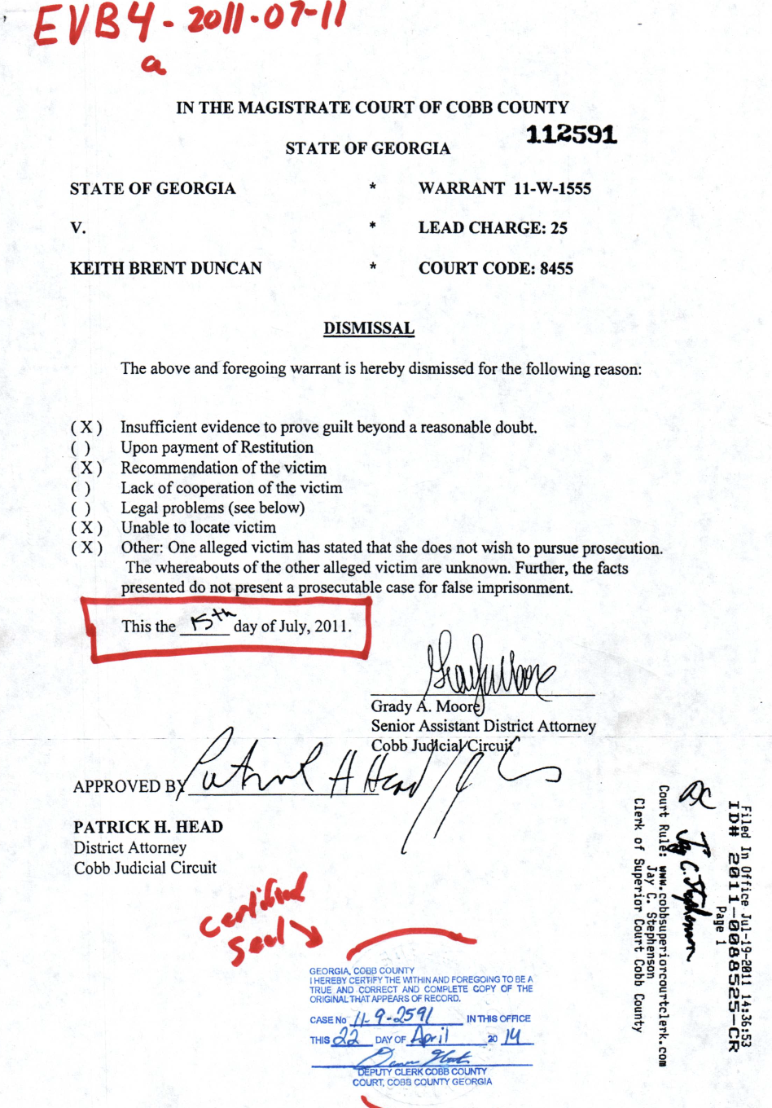
UNIOCRACY.org Intl Headquarters +1 770-377-2106. ENJOIN everyone to Be free Will Sovereign citizens
DuncanClaim.org 22-1-3042-68 $500 Million USD Cobb County GA TPO 11.1.1171 cancelled July 15, 2011 TPO 11.1.7683, MPD 11.1.2506 Robbery NON Violation of Norfolk VA 4:11cr112 rights.
.DUNCANCLAIM.org $500 Million USD 22-1-3042-68 proves all crimes against KeithDuncan.org were Against YOU of UNIocracy.org Who do YOU know to Demand USA GOV accept all evidence showing WHO sent Keith to Earth to UNIFY +8.3 BILLION WE GODs Children once and forever.. 2025 Sept 20
#### End of Gods solutions now 134 Strong ONLY answer methods.
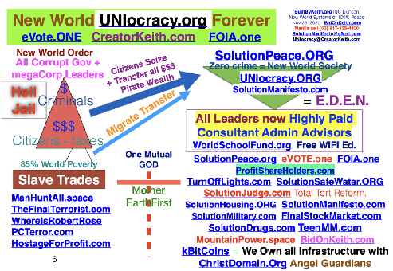
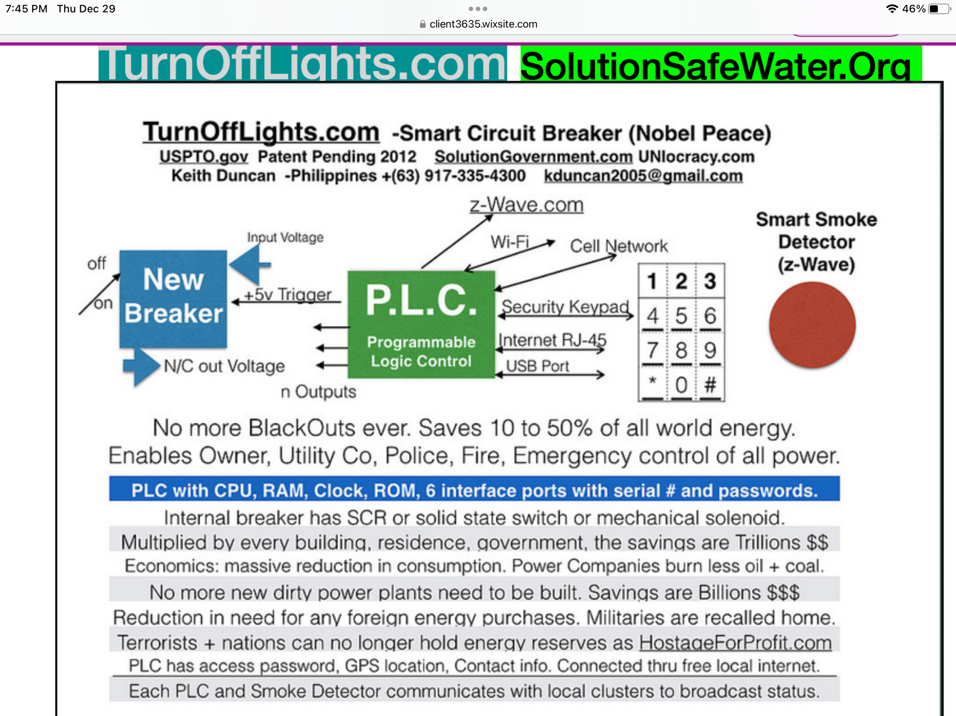
UNIOCRACY.org Intl Headquarters +1 770-377-2106. ENJOIN everyone to Be free Will Sovereign citizens.

DuncanClaim.org 22-1-3042-68 $500 Million USD Cobb County GA TPO 11.1.1171 cancelled July 15, 2011 violation of Norfolk VA 4:11cr112 all rights.
DUNCANCLAIM.org $500 Million USD 22-1-3042-68 proves all crimes against KEITH were against YOU of UNIocracy.org

#### End of Gods solutions now 127 Strong ONLY answer methods.
UNIOCRACY.org Intl Headquarters +1 770-377-2106. ENJOIN everyone to Be free Will Sovereign citizens.
FortuneONE.org CreatorKeith.com
PeaceSummit2020@gmail.com
+1 770 377-2106 Asheville NC USA
UNIocracy.ORG Evote.one FOIA.one Unifier forever

SolutionGUNControl.com
Blue Tooth Trigger Lock (patent worldPTO.com) (c) (tm)
Universal crime preventer of all Gun Violence
- When gun moved or BTTL disabled, owner notified.
- Security alarms triggered, video of theft real time OCTV and k911.pw used notify list of controllers.
- Optional pre register gun or at time of theft. Or only owner group notified of real time crime.
- Includes automatic registration of DOD DOJ solutionMilitary.com weapons. Includes all WMD of tanks, ballistic missies, submarines, aircraft, even drones of SMRCF.com Stone Mtn NewZion2.com

Always requires direct delivery to all national News press so you can be international hero for showcasing all the other anti all crime systems of creatorkeith.com clearinghouse at YouTube.com/uniocracy/playlist

ReInvestALL.com was God and your only solution to destroy the legal embezzlers of coPirates of givingpledge.space and criminal ruling elite.

Now Host Mediate required PeaceSUMMIT2020.com CreatorKeith.com
TheMetaPhysics.Foundation NGOs
PeaceSummit2020@gmail.com
+1 770 377-2106 Asheville NC, Atlanta GA USA +1 725-200-7683
UNIocracy.ORG Evote.one FOIA.one Unifier forever. ReInvestALL.com GODs free New World
Command we host Press Conferences NOW! SolutionMilitary.com TurnOffLights.com
SolutionManifesto.com WorldSchoolFund.org beSmartBeRICH.com
DuncanCLAIM.org !!! +$500 Million USD

Everyone CROSS promote mass publicity REINVESTALL.com and world changing original 100% direct eDemocracy voting of EVOTE.ONE. YOU WILL BE PAID to help eliminate ALL those who cause world mass poverty and all Wars USING these simple ancient GODs methods of 5steps.life generator. CreatorKeith.com is DiscipleKeith.org and original BidOnKeith.com Duncan 770-377-2106 CALL us ONLY if you are not a CYBER SCAMMER Con-artists who YOU now eliminate by use of SolutionLawENFORCEment.com Evote.one FOIA.ONE focusing everyone on ReINVESTALL.com only CU and ONLY SBO private worldwide.

eVOTE.ONE is total economic replacement direct real time eDemocracy voting decision system. These simple GODs four complete perfected replacement Commandment Constitutional Universal laws of SolutionManifesto.com change the course of our human legacy history forever:

1. We vote on Who is the new NEXT Project Manager using FOIA.ONE as worlds last open public shared database of everything.
2. We vote OUT any person who refuses to complete #3 projects. KeithsRulesOfOrder.com multilevel assigned reported tracked proxy system ensures all decisions are made using 5Steps.LIFE agreements that benefit everyone while null and voiding all previous laws and related legally binding agreements.
3. We vote on the NEXT best project by majority deciding on our NEXT best local issue, problem, project, and petition using our assets, times, and tax money. PeaceSummit2020.com occurs monthly.
4. We vote UP, DOWN, or same the cash paid to each leader. This includes WE control all decisions and pay of all our Corporate Executives worldwide. We Null and Void all Stock Options, Campaign Contributors, all special interest group lobbyists, and destroy all legal and criminal embezzlement of our assets and funds.
Four more comprehensive perfected retro-active requirement replacement laws are showcased here.
Worst crimes of WMD of heresy heresay are eliminated by ACTION of WE GODs people SolutionJudge.com

CreatorKeith.com World UNIOCRACY.ORG ANSWERS FOR HUMANITY

### WORLD PRESS re-RELEASE Monthly held Town Hall Forum Conclaves use:

PeaceSummit2020.com Each Host Mediate with ProphetKeith.com +1 770-377-2106

All world Presidents + top Elite Corp Executives Commanded to attend Town Forums.
1. We solve all base world problems 5Steps.life as Public Servants of We Gods People.
2. FOIA.one IID Who is Who. Share all evidence of who are top violators to purge.
3. Assign SolutionMilitary.com to find terrorists Open Public Investigations.
4. Agree to redistribute crime wealth to 3rd world nations in greatest need using Evote.One CreatorKeith.com 1% seized and crowdfunds of +7.9B Gods People.
5. Agree to transfer millions of our young adults to places of greatest needs with WorldSchoolFund.Org 100% free Foreign Exchange Student Keith's Program.
6. Agree to remove all by-laws and regulations that prohibit the immediate deploy of ProfitShareHolders.com from being our new world free trade total barter society.
7. Agree to eliminate all corporate corrupt criminal violators of human rights individuals using Will of Free Citizens use of Gods SolutionJudge.com by EVOTE.ONE.
8. Agree to universal FOIA.one IID and eliminate purge DOJ DOD Corporate Executives who violate laws SolutionLawEnforcement.com + SolutionManifesto.com
9. Protect the lives + Assets of SaintKeith.com + those of highest IQ merit.
All Presidential, Leaders, Corporate Executives Work for GODS people. Reset from Sept 2011. WhereIsRobertRose.com and DUNCANClaim.org
Each of these are CLIENT3635.wix.com/* world self saving solutions.
### May 4, 2023 Total of 165 GODs world reform new world systems (ordered).
5Steps.LIFE. Basic GODs generator procreates all method solutions and life.

CEO CreatorKeith.com (c)(r)(tm)Patent WorldPTO.com 1958-2023
The Meta Physics . Foundation = TheMetaPhysics.org

This is your Universal simple KISS methodology to re create GODs UTOPIA of Heaven as it was original procreated here on Earth. Never been done before for all reasons clearly explained since most mortals have self isolated themselves unable and unwilling to search and find their very own purpose of WHY they were conceived and gifted free will choice of RIGHTEOUSNESS versus EVIL known as sin, vice, and crime.
A short breakdown of the phrase The Meta Physics is below since everyone loves great acronyms versus synonym:
T Theology -Basic belief system of how human souls interact and connect with each other as GIFTERs.
H Health -Without best health of mind, soul, and body little can ever be done to advance our human race.
E Education -State of the art digital communication systems reprograms each of your minds to be careGivers and CareTakers. The only other two groups are our OVERSEER guardian angel inventor investor philanthropists. The last group are the UnderTakers who deal with our end of life mortal deaths led by Gods Grim Reaper.
M Math -The basic method of determining anything of value benefit to each other.
E Engineering -Basic problem solving method technique to advance our human race as peace makers.
T Technology -self evident.
A Architecture -required to scope out the near perfect design of any creation at all levels.
P Physics -The in depth study of cause and effect of how all of Gods creations interconnect link to each other. Everyone and everything has a ordained divined reason for being in expanding existence. Ask us about the 'White Elephant in the Room parable."
H HOME -Everyone deserves to have a stable base of operations their entire lives. The homeless and impoverished only exist because of the 'Criminal Ruling Elite' who commercialized slave trading genocide 5550 years ago in Egypt.
Y YOUTH -Our best resources is our children and young adults who must be open public trained how to be World Leaders to replace our aging elder group of master problem solvers who inherit all our knowledge from previous generations.
S Satisfaction is Happiness. This always occurs when our work efforts are 'GOOD ENOUGH near perfection' requiring no more effort, time, or resources to refine our creations any further. THEN go forth to teach others everything you know.
I Integrated. Once everyone understands they are always MORTAL and WILL DIE either a happy or cruel death, each of you will now decide to be a GIFTER CareGIVER who shares everything with our CareTakers, and Overseers.
C -Care Communication Command Control is defined as GODs original LOVE. The command must come from each of you having full confidence to address any issue that negatively impacts the minds, souls, bodies, and assets of all others.
S System -Defined as the required fast path methods of deciphering observing any issue problem conflict, then documenting the best 5Steps.life generated video/audio/paper methodology to obtain the better = best solution that becomes how to PREVENT and Reverse the original root problem. Includes reversal of all WarLord Machines.
Always required to HIRE and USE Keith brent Duncans most profound simple disruptive gifted methods for each of you to finally learn how to be ONLY PeaceMakers and PEACE Gifters once and forever.
Immortality is the exact opposite of Immorality.
https://en.wikipedia.org/wiki/Outline_of_metaphysics
Contact debrief protect Keith Brent Duncan today.
+1 770-377-2106, +1 725-200-7683
info@TheMetaPhysics.org

FortuneONE.org CreatorKeith.com
PeaceSummit2020@gmail.com
+1 770 377-2106 ATL, Asheville NC USA
UNIocracy.ORG Evote.one FOIA.one Unifier forever

SolutionMed.org
4 simple steps To PREVENT, then Reverse Spider web Spread of any pandemic disease and/or Crime enterprises, here is GODs original technology methodology procreate author gifted by Keith Brent Duncan, BidOnKeith.com (c)(r)(rm) This worlds Patent valued + $100 Trillion USD.
1. First carrier of any new disease (or crime method) travels remotely by stealing, lying it's theft identity, then hiding from detection while recruit converting next layer ring of victims to continue the spread outward until all consumable material or energy is depleted. First traveler of any new disease obviously infects those in close proximity. Once they are diagnosed with a new viral disease, the following data mined driven solutions prevent the pandemic spread in less than 6 weeks based on statistical data modeling perfected some 40 years ago by Keith.
2. With advent of GODs technology pioneered by Keiths elder #1 top computer science engineering groups, the first report of the issue must be shared with public through FOIA.ONE. All Phone Companies, CheckPoint officials, even Open Circuit TV auto face recognizes each person. All cell phones are constantly recorded of our GPS locations triangulated by wifi routers and cell towers WE GODs people paid to construct and maintain.
3. Simple SQL matching of medical records and GPS locations, our system notifies large percentage of possible infected citizens to self isolate and be tested locally to prevent mutated effects. REVERSES ANY PANDEMIC 6-8 WEEKS.
4. Worst WMD are genetically modified DNA weapons of mass destruction including original SIN of LUCIFER agenda heresay. He said, She Said used to persecute + murder the most intelligent scientists who work for GOD and each of you. ONLY when all medical scientists and Doctors SHARE research information will all Diseases be reversed.

FortuneONE.org World Overseers MegaBillionaires.

Resume for Keith Brent Duncan.

As of Feb 2023. Atlanta GA USA 1958-2023 (c)(tm)
In China + Manila since Aug 2015. Now in Atlanta GA, Asheville NC info@FortuneONE.org
+1 770-377-2106. +1 725-200-7683. Born FOIA.ONE IID 1-19580815-1 High Point NC USA.

Overview: Full expertise is at original 1976 BidOnKeith.com and +110 broadcast one public solutions includes Evote.ONE FOIA.ONE, REINVESTall.com WorldSchoolFUND.com SolutionMilitary.com SolutionManifesto.com SolutionJUDGE.com with focus on EcologyMining.org KeithAirService.com LaserTunnel.com ECRAFT.us SKYLIFT.us, TurnOffLIGHTS.com SolutionSafeWater.org new world crime free independent fully liberated communities once everyone uses PeaceSUMMIT2020.com broadcast world saving unification solutions. We were always the most brilliant highest IQ scientist engineer researchers, manufacturing experts known as angel Guardian wealthy philanthropists who control all other mega billionaires of GivingPLEDGE.space
youtube.com/@keithDuncanUNIocracy is partial +700 GODs messages.
YouTube.COM/UNIocracy/Playlist
Our most prolific patents (c)(tm) we have always gifted to all mankind to solve prevent any problem once everyone uses Gods Generator of FiveSteps.life. This updated Oct 11, 2022 DuncanClaim.org

Early Beginnings; Starting in 1976 North Carolina State University Raleigh N.C. USA, our fusion focus from day one as top world scientist engineer consultant architects was to create an all digital electronic driven no paper fully robotic automated crime free society. We have succeeded as of 2011 timeframe by construct engineering and deploying the most comprehensive and even simple systems that unify mankind once everyone in world now knows WHO is WHO, WHO owns WHAT, WHO trades WHAT with WHO and GPS tracked when and where. FOIA.ONE Evote.one is part of UNIocracy.org new world replacement market system that is 100% hack proof and can never be infiltrated by any cyber criminal or network.

Our focus was amateur radio W4ATC and the deepest study of mainframe operating systems at all levels of databases, computational matrix decision analysis, creating 3rd and 4th generation computer languages mostly in Assembler on IBM 370/165, then PDP 8, then immediately taking Electrical engineering courses on micro electronics hardware, software, and of course the underlying data communications protocols that run our entire world. These are known collectively as Programmable Logic Controllers. Our key achievement is TurnOffLights.SPACE that is all electronic interconnected data communications and related FOIA.ONE database that are the ultimate simple format of cluster network data exchange of all data in the world.

1981 BB&L Industries was startup in Atlanta Georgia as we produced the worlds most state of the art Paging and voice retrieval systems in the world.

1983 Rollins Inc as I worked directly for President Randal Rollins specifying at the lowest to top levels their new 40,000 unit ITI Security system and monitoring central station software and hardware. After 9 months, I saw they were not going to invest in the required in house development group that I was leading.

1984-1989. Digital Communications Associates. As top key member of their engineering design production teams, I as the International Design engineer as we are the top scientists who created key components of all inter connected banking, finance, phone company, stock market, and data communications protocols and high speed dedicated hardware interconnecting the new IBM PC technologies, the AT&T UNIX systems, and IBM and DEC mainframes worldwide. I traveled extensively in Europe by creating the automated international language translation of all software systems of IRMA and SMART ALEX.

1989- 1992. As top key consultant of Broadway & Seymour, we were the top world consultants on the IBM high speed check sorting systems, then the famous IBM DataTrade system that was the worlds first computer independent software system that transmitted any data (mostly banking) from any hardware based computer at PC, midrange, to Mainframe level using only ONE major source code repository that was written in 100% generic cross compilable C language. We also worked at Dupont on their factory automation systems.

1993-1994 SunGard Trust Systems Birmingham Georgia. Our small teams created and deployed the most expensive Portofolio management investment and tracking system at that time. Managing billions of USD/Euros through IBJ, Integrity bank, and of course all the huge customer bases of IBM and other banking consolidators like Carnage Mellon.

1995-1996 AT&T (Bellsouth) We were the core consultant teams who designed AT&T’s replacement construction Managment supply chain system of OSPCM. In less than 1 year we were fully operational after designing their new system from ground zero.

1996-1997 AT&T (Bellsouth.com) Long Distance. Our top consultant teams were the original designers of their very first long distance billing system we designed from ground zero. We were operationally in less than 1 year as our work dealt with millions of call detail records and the wholesale billing to sub vendors and interconnections with all other phone companies.

1998-2004 bellsouth.com As top consultant, we were the lead consultant architects of the prime mainframe to web portal Bellsouth billing and product/ service procurement site managing over 70 mainframe services for 24x7 service availablity. We had the highest usage rate of any world corporation including Google, Amazon, IBM or any others. We had the lowest failure rates because our prime focus was on sustainable tracking of all software modifications and predictive analysis software systems to prevent major computer malfunctions and shutdowns.

2005-2007. Datatrade that services almost all Toyota and other major brand auto showrooms.

2008-2011. Is the most incredible verifiable years when we were asked to partnership with the top Home/business highest end electronic automated system vendor in Atlanta GA. After being defrauded of $109,000 USD, we embarked on the most positive profitable journey of all time. HOW to UNIFY mankind by create publishing the required HOW-TO produce almost free electric energy worldwide with TurnOffLights.SPACE, SolutionSafeWater.org.

Sept 2011 to Jan 2014 were extreme educational publishing period of the inside of our very own Judicial system at all levels. We published the true cause and effects of Poverty from 2005 to present because no one else has the confidence to deal with the real numbers of trade and who controls our data, assets, and liberty of free speech, press, and ability to redress grievances against those who violate our laws. This is SolutionJudge.com SolutionManifesto.com completed to perfection years ago. Our world is legacy heritage value because everything gifted back to our world to be happy.

Our resume and most broad spectrum experience is so extreme that we have not the time to keep repeating the most obvious fact of all. We are the original pioneer free will citizen scientists who were the instrumental top experts in the world who designed and deployed almost perfected hack free systems. Our work in the psychology of the HUMAN CONDITION has also been perfected in our ability to teach humanity at all levels how to be peace loving citizens when everyone benefits by fearlessly protecting the rights of all others.

This was always our mission in life. TO be GOD LOVING free will open democracy public citizens who defend the rights of honest integrity focused citizens so that everyone benefits down to the very most impoverished orphan homeless street child with WorldSchoolFUND. Once our young adults use TeenMoneyMachine and other existing educational all digital resources of ISeeStand PHONEcradle seen on CreatorKeith.SPACE, they collectively become our new world leaders of commerce leading small corporations as the MEGA corrupt corporate executives will be banned from leadership by the will of majority bell curve mean 7.777 billion people using simple 5 steps of Evote.one part of SolutoiNManifesto.com Our prime world saving solutions are the worlds last replacement law enforcement system when all agencies share criminal investigation evidence to the public so everyon prevents crimes in the first place. Ties to SolutionMilitary.com as ONE International military as 100% peacekeepers and criminal investigators who are no longer controlled by Presidents, Congress, or military industrial complex share holder executives.
We have successfully replaced all stock market trading computer programs by eliminating the ability for anyone to day trade with insider information by using OUR bank accounts and stock market certificate value to criminally profiteer since only a few executives and bankers actually control the master passwords and have access to our private trae and commerce activities.
SolutionHousing.org is the prime legal method to successfully transfer true trillions of USD of wealth to higher elevations in 3rd world nations and under development remote mountain regions to unload the worst cases of mega slum congestions that are 90% of our world population located in coastal flood disaster prone cities. Manila is #1 most dense per population of any nation.



We have requested that MILITARY escort us to debrief DOD, DOJ, PRESS, and all World Presidents and PUBLIC from Sept 2011 to present moment for all reasons of how to UNIFY mankind in GOD’s original purpose for humanity to reach for the stars as Sovereign Ambassadors who teach PEACE and not war.

Our rare GROUPS are the fore founding fathers and Mothers PROCREATORS of UNIocracy.org with FOIA.ONE IID 1-19580815-1 (Integrity Rating +101%)
We the PEOPLE now own and control everything based on the most common sense method of 100% direct eDemocracy. This was ready for world deployment military style back in summer of 2010 and was the full scale target of Robert Dee Rose and others who are named individuals. Never our fault, we have keep full records of everything related to the HUMAN CONDITION and have gifted everything back to ensure humanity follows their own destiny direction as FREE WILL peace abiding Social Justice and full scale equality people. No more bigots, hypocrites, racists, or arrogant people can ever escape the open public TV eDevices we pioneered ourselves 1976 to present momentRequirement is always to PROTECT KEITH and his top level scientists as our goal is to eliminate the need for ANY POLITICS, TAXES, PRIVATE SCHOOLS, and anything owned and controlled by the FEW elite who everyone truly hates. Most have been brainwashed by the occult to think no one can be held accountable for violating basic human rights. SolutionManifesto.com manages that one required Due Process of all laws with just one website client3635.wix.com/SolutionManifesto.
.
Contact our growing teams and join support and fund UNIocracy.org today.
Direct to All Executives. Gary Rollins, Pam Rollins, and CEO Richard Hubbell of RPC.net ,
Date: 2022 Oct 24, 2023 April 25. ShareHolders Meeting.
From:

SolutionEnergy.us EcologyMINING.org was LaserTunnel.com CEO founders of new world UNIocracy.org publishers and Angel Guardian VC philanthropists.
SolutionEnergy.us LaserTunnel.com KeithAirService.com
FortuneONE.org CreatorKeith.com OneNews.Foundation
PeaceSummit2020@gmail.com
+1 770 377-2106 Asheville NC USA
UNIocracy.ORG Evote.one FOIA.one Unifier forever.
ReInvestALL.com GODs crime free New World
Command we host Press Conferences NOW!
TeenMM.com SolutionMilitary.com TurnOffLights.com
WorldSchoolFund.org beSmartBeRICH.com
DuncanCLAIM.org !!! $500M USD

We request you direct call us at +1 77377-2106 and meet us to discuss partnership, funding, and technology we procreated year 1976 forward to reverse ALL climate Change $$$ conditions worldwide forever.

We have always represented the best interests of our common citizens, All legally authorized Government officials as well as all corporate executives worldwide.

As FortuneONE.org, we have procreated +100 NGO corporations to literally SOLVE each of mankind basic needs for unlimited electricity, power, transportation, Land use, water, food, and basic infrastructure now completely owned and managed by each localized communities worldwide. Never been done before by leveraging existing and ancient technology so everyone now sees WHO is WHO, Who owns What, and who trades what with GPS traced WHO at all levels.
LaserTUNNEL.com requests your direct conversion of RPC.net all company resources and technology investments to drill massive water and infrastructures UNDERGROUND since our original 1976 inventions of TurnOFFLIGHTS.com SolutionSafeWater.org eliminated the need for almost ALL FOSSIL FUELS. Current past 120 years, all energy systems have been legally perverted and diverted by use of STOCK OPTIONS and insider day trading manipulation of GODs resources. WE are currently new members of RUMC.ORG Peachtree Road United Methodist Church and even sing in the CHOIR. We are deeply saddened by the demise of Randal Rollins as we personally were his direct assistants under Phil Brader year 1983-1984 as the worlds most trustworthy top expert in all electronics and psychology methods of same UNIFICATION of all mortals once and forever. We personally attended the April 2022 Stock holders meeting and actually met each of you and personally handed Gary Rollins the SAME world saving solution answer method sets.

KeithAirService.com now direct funded by any Corporate Executive groups who abuse their power and control authority over OUR profitShareHOLDERS.com

This is done by mass publicity of simple ReINVESTALL.com that compresses all the worlds best business practices back to ONLY privately held controlled Small BUSINESS that are NOT publicly traded as commodity speculations. Includes elimination of all banks world wide by decentralizing all of OUR wealth assets and knowledge back to only locally owned and controlled Associated Credit Unions in each community.

KeithAirService.com is the fast path method of our stockholders making STOCK OPTIONS and golden handcuff perks like Deferred Compensation and corporate aircraft null and void.

Over 20,000 USA based corporate jets and turboprops are being used by mega billionaires to conduct secret business deals and so many private family trips all at the expense of WE THE PEOPLE shareholders.

Best true example is Warren Buffet who NEVER pays $5K to $20K per flight hour when he uses one of our 700 netJets.com

We have 100% focus on simple fast path universal methods to eliminate all criminals and terrorists worldwide use of simple eVOTE.ONE CCWGuard.org SOLUTIONMANIFESTO.com and SolutionMilitary.com to teach all mortals how to protect our communities from predators at all levels includes all the cyber criminal terrorists who all roam freely like ROBERT DEE ROSE at DUNCANCLAIM.org value exceeds $500 MILLION USD based on one judge signing required court orders we have been producing full time post Jan 15, 2008 HomeWaves.com 3 promissory notes.

Please contact us ASAP as we have best greatest news to spread that ALL privately held corporations will now openly trade their products and services with NO FEAR of any government regulators, MORE LAWS, MORE TAXES, more policy political warfare than only PROFITEERS the very very wealthy elite like the original JP MORGAN groups includes the Vanderbilts at BILTMORE CORPORATION.

None of our extreme simple published economic observations are exaggerated as current news event show that martial law and terrorist attacks will continue to escalate since NO ONE has ANY CONTROL or AUTHORITY over the FEW who claim ONLY THEY are the COMMANDERS in CHIEF and decision makers only at the TOP of the ‘HEAP”.

Kindest regards, Keith Duncan. +1 770-377-2106

When and WHERE can we meet ASAP as we have NO other solutions from GOD to publish and showcase.

AMBERprotect.org ChildProtectCoalition.com

### World Press re-Release 2023Feb20 (c)(tm)(r) Patent Pending 2023 FortuneONE.org
Keith Brent Duncan. +1 770-377-2106 for all to call, debrief, and protect our lives until all criminals and terrorists are swiftly identified, investigated, found, sentenced to Prison and Death Row by orders of all affected Victims and local community all Peace Making our leaders.
CLICK Reference: https://en.wikipedia.org/wiki/Amber_alert
Most Critical of all time: Keith and his overseers have already provided ALL the direct required funding and patented technology specifications for ANYONE to replicate use our methods for their very own SBO small business owner benefits of REINVESTALL.com of no more Banks OR Public holding traded any IPO stocks.
AmberProtect.ORG (c)(tm)(r) Patent Pending 2023 is another, actually LAST major perfected all encompassing compassionate patented GODs technology to PREVENT threats and abduction of our children worldwide, includes the millions of orphans and street 'LOST BOYS and GIRLS'. Based on continuous re-broadcast of FatherKeith.com original SolutionGunControl.com iseeGranny.com and other most prolific world and soul saving inventions of GODS technology.
No one else has ever procreated worlds last open public no secret no crime society of GODs UNIocracy.org of GODsConstitution.com means NO more any corrupt anyone using GOD + Keiths simple methods.
Procreated on emergency basis 2023Feb20 after direct conversation with Tom Haag and PRES + Condance.Pressley@wsbtv.com at her direct cell 404-897-6297, NewsDesks like WSBTV 404-404-897-7600 or YOUR CHOICE. Condance was my dear friend who personally invited us and co-hosted Sept 2011 Sept WSB 750AM 1.5 hour of IseeStand.org and teamMoneyMachine.org to self liberate all 8 billion OF GODs people at one time use of Evote.ONE and other solutions* all preconceived year 1973 then 1976Aug15 NCSU Raleigh NC showcased at Keith2022.com
Really beyond believe and acts of Criminal Ruling Elite who are most 'Criminally insane incompetent' that few if ANYONE actually has the confidence to ask KEITH any question and hear believe the best Solution of GODs all generated by GODs original generator 5Steps.life
NOTE: Criminals and Terrorists always genocide, murder, rape, pillage WE the PEOPLE past 5550 years once they claim ONLY THEY control everything GOD procreated for us. Egyptian Pharaohs were first recorded Lucifer Worshipers who used terror and threats to enslave millions of We GODs People.
Keith Brent Duncan is the greatest inventor, scientist, researcher, maker, human rights activist gifting Angel Guardian Protector Investor Philanthropist(s) of GivingPledge.space value exceeds $40 BILLION USD in intellectual property seen TOP of GODs UNIocracy.org.
AmberProtect.ORG is the simple patent with following benefits and already procreated scientific engineered features, functions, and specific specifications to PREVENT any sexual or other predatory from abusing, raping, murdering, cutting up ANY of you at all levels.
PRIME ISSUE: Once a sexual predator stalks, grooms, and kidnap, abuses, murders our children, TOO late to save our childrens lives as the ones who survive are emotionally damaged for life like Charles Rogers of ChildProtectCoalition.com at 404-579-5615 through Atlanta AG Chris Carr and FBI special Director JC Hacker who always knew WHO WAS KEITH DUNCAN.
Benefits: Each preprogrammed and custom programmed GPS sensor touch switch is configured as alarm based on specific conditions of location, carrier, time of day, and other parameters.
Programmable features and demonstrated examples:
Off the shelf GPS trackers like Apple ITag are now easily outfitted with a trigger pressure switch and even a external activation key. current GPS technology are two way transmitters through any BT phone and/or router with variable detection distance of 20 to 100 feet, actually more for our advanced models.
Lack of signal over specified time period also triggers the AmberProtect system to notify the list of parents, authorities, and even principals and others in care charge of our children, elders, disabled, and anyone who has previously been stalked and threatened listed on the Sexual Predatory Database of Keiths FOIA.ONE. Convicted predators are also required to carry and use these AmberProtect systems to indicate if they stalk and harm more victims by order of WE GODS people use of universal EVOTE.ONE direct 100% real time decision methods from Keith.
The programmable trigger switch now used to indicate level of danger of the victim. mounted on belt, in knapsack, or even in pocket, easy to 'morse code style' transmit the situation. Even the turnoff or inactive non motion is programmable to trigger correct authority response action notifications including activating CCTV and/or Keiths Open Circuit TV open public Monitoring face BIOmetric system to fast path who is causing the primary and secondary threats to We the PEOPLE of UNIocracy.org
Content | Video title
Total
_bE6961g8i8 | #1192 Kathy Duby in Dekalb County GA evidence of crime sprees against GODS PEOPLE reversed eVote.one
qt49mlci7CQ | #1194 @BuiltByKeith DuncanClaim.org $500 Million Criminal Conspiracies reversed EVOTE.ONE FOIA.ONE
u_dl91Y24-8 | Bela Talon High Performance Turbo Charged Show Car For Sale. Atlanta GA. ProHeadLightRestoration GM
jA20iNkC8EA | #1194 @builtbyKeith @creatorKeith Gods procreator Keith2022.com evote.one Reinvestall.com no evil.
rxBkZnqeoVw | #1194 @BuiltByKeith GodsCrusade.org SolutionPeace.org UNIocracy.org Destroys All Lucifer Worshipers!
Kx9dPTUexq4 | #1190 BuiltByKEITH UNIocracy.org Gods evote.one foia.one replace all leaders forever ReInvestALL.com
Zzut1W_9ALc | #1193 BuiltByKeith Gods SolutionPeace.org UNIocracy.org Re-Education of ALL to destroy Lucifers
P3Xpr5uEUAc | #1194 Builtbykeith ProphetKeith.com GOD sent UNIocracy.org EVOTE.ONE PeaceSUMMIT2020.com FOIA.ONE
2S19lPsm89w | #1193 BuiltByKeith ReInvestALL.com overthrow by Gods UNIocracy.org EVOTE FOIA PeaceSummit2020.com
U_tkw0FMmWE | #1191 BuiltByKeith who wants Gods $40BUSD FortuneOne.org NGO +100 Corporations ReInvestALL.com Evote
le9ZgAWJCT4 | #1191 BuiltByKeith FortuneONE.org eVOTE.one FOIA.one ReINVESTall.com ee911.us PeaceSummit2020.com
pOrjit0IrCk | #1194 @BuiltByKeith Stage Mass Peace Making Rallies NOW UNIocracy.org eVote.one PeaceSummit2020.com
zeV0pf4E2Zg | #1194 @BuiltByKeith UNIocracy total perfect Unify evote.one Foia.one reinvestall forever 7703772106
sjpnWg8R33k | #1192 BuiltByKeith Gods UNIocracy.org ReInvestall.com perfect EVOTE.ONE FOIA.ONE PeaceSummit2020.com
OWkJZ7k7kOo | #403 RebuildCagayan.PH UNIFIES all Mankind UNIocracy.com BuiltByKeith Kingdom
hcV6rAKSdq4 | #27 BuiltByKeith SaviorKeith.com evote.one FOIA.one Solution Provider ALL MANKIND Christ's GODson
oq9mn24smNU | #1191 BuiltByKeith FortuneONE.org $40BUSD EVOTE.ONE ReInvestALL.com #1 TheMetaPhysics.org foia.one
8OzBCVhW7u4 | #1192 BuiltByKeith #1 Revolution SolutionPeace.org theMetaPhysics.org PeaceSUMMIT2020.com FOIA.one
H1yBAvZ28qA | #1173 builtByKeith manHUNTall.space Robert Dee Rose super terrorist Death Row norfolk Va 4:11cr112
I9-IHd9TNOU | #1194 Builtbykeith Road Warrior sent by GOD is UNIocracy.org EVOTE.ONE PeaceSUMMIT2020.com for all.
MYYKiNq0elI | #1191 Dennis Chernonog Roswell Ga Aug 28, 2022 SolutionDrugs.com psychopath evidence committal evote
NpL0myu1vqE | #1193 BuiltByKeith Gods #1 PeaceMaking Revolution UNIocracy.ORG EVOTE.ONE FOIA FortuneONE.org All.
z1lDhDKUPKc | #1192 BuiltByKeith cyber terrorist Robert Dee Rose crimes 6326 Brandywine FortuneOne DUNCANClaim.org
1W9NiNLIlDA | #1081 SolutionHousing.org BuiltByKeith ends all poverty EVOTE.ONE SolutionPeace.com FOIA.ONE
5P6qjMH04jI | #1193 BuiltByKeith Gods Free No Crime SolutionPeace.org UNIocracy.org EVOTE FOIA PeaceSummit2020.com
78-NT-8-bSw | #1174 BuiltByKeith Gods System SolutionHousing.org is ProfitShareHolders Revolution xFer Forever.
Asu8ZoOQYsE | #1191 BuiltByKeith HLV KeithAirService.com ReInvestALL.com HelpInmates.com ProfitShareHolders.com
BBBzYvXfUXQ | #1193 BuiltByKeith EVOTE.ONE Gods SolutionPeace.org UNIocracy.org FOIA PeaceSummit2020.com Heaven.
Ib1_zDFSjcw | SolutionSafeWater.org Clean Water SchyTech Eng Harry Frieres famous Inventor
YdiNj4OU-1M | #2 Glow MyBizPeople.com Coffee, Coconut 21 World marketed products. Call us.
jRFUXlrpl8s | #1192 BuiltByKeith FortuneONE.org Revolution EVOTE.ONE FOIA.ONE destroys ALL politic crime forever.
kH7IBQn7jwo | #25 BuiltByKeith FollowKeith WASH the SIN to cure Washington of Corruption. DEMAND ACTION
qc3goqXSxV4 | #1187 BuiltByKeith $500MilUsd duncanClaim.org unifies all evote.one mortals Foia.one CreatorKeith.
vo3cCq3uxdo | #1172 BuiltByKeith TurnOffLights.com reverse all fossil fuel wars forever EVOTE.one solutionMilitary
2AeLo29nZyQ | #1170 BuiltByKeith Infamy ManHuntAll.space solutionManifesto is UNIocracy crime evote.one free4All
2MfBc-gRqCg | #305 Cobb Cty 11.1.1171 TPO Ms Bashama Thief-Robber-Conspirator exposed BuiltBykeith Children
2e5ON3-A36E | #161 GODs timing is UNIocracy solutionURL.com BuiltByKeith saves HUMANITY.
2twoQ4ydYlM | #116 BuiltByKeith UNIoCracy.com BuckHead SaviorKeith MasterMind Prevents CRIME forever.
3pOiwNQu9kE | #1185 BuiltByKeith Gods UNIocracy.org EVOTE.ONE FOIA.ONE ProfitShareHolders.com PeaceSummit2022.com
6RwkCSfSBV4 | #1190 BuiltByKeith Gods FortuneONE.org redistribution of reInvestALL.com wealth command authority!
79b5atpT9-o | #1080 BuiltByKeith eVOTE.one FOIA.ONE Sweeppp #1 education Training WorldSchoolFund.org BidOnkeith
Dgj4InPGK5E | #1190 BuiltByKEITH FortuneONE.org ReINVESTALL.com Gods UNIOCRACY.org solutionHousing.org eVOTE $40b
F_L5hHFxU9c | #1176 ProphetKeith BuiltByKeith ends world life soon solutionManifesto.com centerWorld.space
FfnwaS7xt8I | #383 Kill all Terrorist political Crime with SolutionGovernment.com BuiltByKeith.com FatherKeith
If AmberProtect goes outside a preset GPS boundary includes during specific time periods, ALERT is sent out.
Above most prestigious and affordable technology will also be procreate manufactured, distributed, manage, maintained, and upgraded by EACH of YOU, my most beloved 8 billion WE GODS children forever.
keith b duncan was always ProfitKEITH.com sent by GOD to unify each of YOU as WE and US.
Following is partial list of YOUTUBE.com/@UNIocracy demonstrates real time WHAT Keith Brent Duncan has done to unify mankind full-time his entire 64.666 years of life serving GOD and all humanity at same real time. Actual list is thousands of broadcasts, all stored on DropBOX.com to be deposited into GODs FOIA.one one day very SOON by your efforts.

BBK20160826-13PlaguesRevelations-SolutionManifesto-393

Friday, August 26, 2016 #### World Press Conferences and re-broadcast. Friday, Aug 26, 2016
Thursday Aug 25, 2016 was another busy day by FatherKeith.com Duncan in the the Holy Trinity Name of humanity, God, Christ, and the Holy Spirit. It takes four entities to actually have a universal collective conscious called life. Almost our entire world is in survival mode of finding basic food, shelter, water, and protection from the basic periodic elements of the nuclear age. This includes protection from the criminal elements who are almost all of your own government and corporate leadership. They have obtained their evil kingdom thrones of ultimate power because they ruthlessly abuse the rights of those who have elected and promoted them. For the survival of the strong fittest, is now the conquering ability of those who have the intellectual quotient (IQ) to enslave those around them at every opportunity.
How many politicians promise exactly what their constituents need, then raise millions and collective billions of $$$ for campaigning, get paid off (bought) by criminal agents of mega wealthy Criminal Ruling Elites = MonkeyKings.info? Then once elected, they use the power of their office to prevent everyone from seeing they are dipping their hands into the blood stained taxpayer coffers to feed their own political and criminal enterprises. They buy their way out of all criminal proceedings by extorting the judicial system using taxpayer and criminally acquired funding.
The news media Press is just as criminal as they are typically interested in only profits from advertising revenue. They report only the most scandalous and exclusive news as the cycle of fresh blood meat news changes every day. Citizens seldom follow any story and simply do NOT CARE how reality is systematically destroying their assets and livelihoods.
Criminals like Cobb County District Attorney Berry Vic Reynolds attend church, host prayer meetings, advocate for elder and children rights, kiss babies and old ladies at every photo opportunity, yet they run the most insidious criminal enterprises because they control the court documents, the prosectors evidence, and work hand in hand with the most corrupt judges in world history. None of these factual testified statements are speculation, conjecture, or hypothesis. These criminals were criminally incompetent to destroy key evidence and to certify sign their own names on false testimony that includes their ability to electronically weasel their way out of the rat invested worm holes they have dug for themselves.
On Thursday, I visited the new local Health Spa run by my Palestine friend who married a Philippine lady like I did. He sponsors 24 students at the local college. Next I went to Golden Press to photocopy my most powerful business cards and to set a NEXT appointment with Ma Belen Barias-Lim (CPA) manager publisher of The Northern Forum (Harbinger of Truth). MabelenLim@Yahoo.com GoldenPress_Tug@yahoo.com.ph.
Then I visited St Peter Paul Cathedral (Roman Catholic) to set Next appointment with Archbishop Sergio Utley and Edgar ‘Gary’ Agacoili. I met Gary one year ago to describe the horrors of humanity and the Solutions to transform crime reality into the Corruption Free world of UNIocracy.com I video recorded that whiteboard history lesson and posted on YouTube.com as …
Then to exchanged some of my very last USD into Pesos at dropped 46.10 rate. Then 30 minutes at the Bambo Radio Station for second visit to meet their station manager producer. Then the second visit to Nancy Cortez-Garcia at the Cagayan Star ‘Weekly Newspaper in the Region’.
NancyGarcia_87@yahoo.com, I text messaged Philippine Inquirer again about SolutionGovernment.com.
#### World Press Conferences and re-broadcast. Wednesday, Aug 24, 2016!
This posted on FaceBook.com/BuiltBykeith today at 11 am Manila timezone Philippines.
Broadcast to all. The 10 Revelation World Plagues are listed below.
RISE UP, I command humanity, to overthrow all corrupt politicians and bury all criminals once and
forever. Very few of my 7.44 billion people can see they have been enslaved by satanic criminal individuals. The first photo is from DailyKOS.com of a lightning strike in Arizona. The others are the #1 world clearinghouse strategic ONLY solutions to solve each of mankind's root conflicting issues. Use bidOnkeith.com to crowd fund the #1 Crusader of God's sovereign rights while governments and corporations collapse from the massive corruption that has always been #1 world evil.
page 1 of 8
BBK20160826-13PlaguesRevelations-SolutionManifesto-393 Friday, August 26, 2016 Failure to ACT results in depopulation of earth by cultural and energy wars to isolate each of you from
the last Integrity driven leaders that I have asked to join UNITYurl.com
BuiltBykeith google Adwords campaign remains a huge expense with absolutely no response ACTIONS after years of full time broadcasting. The keyword Politics is expensive and tends to kill the impressions once a few people CLICK and never, ever take ACTION.
I am truly OUT of my own extensive lifetime cash reserves and will be struggling to find minimum cash to feed my family after about 2 months more despite living in extremely frugal conditions. I have about $2,500 USD left after all my bank accounts, 401K cleaned out, my prepaid condo-car motorcycle sold off with all my lifetime evidence/possessions with a Forged Power of Attorney, and my rights viscously denied for 8 long years of pure hell. We do not even have running water in our new home. I lost +$1.2 million in hard cash + assets to career criminals ROSE, Ms. Bashama, my own Duncan clan, murdered Brian Walker, and the absolute most sinister Government officials in world history. All based on biblical and logical fact that I reported all criminals to Law enforcement, to the Military, Congress, Public, and PRESS before I was brutally kidnapped Oct 3, 2011 by ROSE's extortion orders. ROSE has a $2 Million USD bounty on his head with Ms. Bashama $10,000 bounty to be paid BY USA government once they SEIZE my assets held in their serpent fangs of satanic devil worshipping teeth.
What can you do? Apparently very little, like IntegratedMediaOne.com without being paid + $500 per month. ANYONE can CITIZEN ARREST the true criminals, chain them to the front doors of FBI-AG headquarters with hard copy documents of their crimes. This includes DAG Sally Yates, Judge Raymond Jackson (Norfolk VA), ATF William Banks, or any of the police, judges, investigators, prosecutors, my own LIAR-LAWYERS tied to two Cobb County Georgia USA of TPO 11.1.1171.99 and 11.1.7683.99,Marietta PD larceny 1.11.2506 Or dress them in bright red prison jumpsuit, shackle them hands to feet, place them on the biggest JACK-ASS mule, and march them down main street to the local BIG HOUSE JAIL. Everyone asks as they live video stream, 'Which one is the bigger jack-ass? The one on top or bottom?" The same applies to well over 30 firms I have hired over past 8 years to GO PUBLIC with any and all of the World
changing Solutions seen on updated BuiltByKeith.com
I have reused other prime photos of massive warnings of plagues that have already descended on mankind.
1. Political Corruption PCTerror.com solved with SolutionGovernment.com to kill all criminal profiteering forever.
2. Slave trading-genocide shown on HostageForProfit.com and KSHAMA.me (the ultimate forgiveness)
3. Cybercrime terrorism ClearCollarCrime.com solved with URLident.com and SolutionJudge.com
4. Underground criminal enterprises in cabal league with gov and corporate leadership. Interpol URLident.com Referential Face Recognition universal database.
5. SolutionDrugs.com with SolutionMilitary.com . Kill the demand eliminates the need for any supply.
6. Abject Poverty homelessness solved with SolutionHousing.com and MaryRights.com
7. Energy wars solved with TurnOffLights.com Smart Circuit Breaker and Smart Smoke Detector.
8. Cultural and religious brainwash wars solved with unification of all denominations with ChristDomain.com SolutionGod.com SolutionIslam.com with IcStand.com PhoneCradle.com
9. Health, children, elder care IseeGranny.com (actually +10 others) using SolutionFinal.com 5 steps to solve any issue.
10. Overthrow of humanity by Satanic Illuminati Forces known collectively as the Criminal Ruling elite. Solved forever with SolutionManifesto.com and 1 Cor 13:13.
11. Education. The root evil is the brain washed consumer who works as a slave to ‘BUY’ the next bling, cool item and expects his future income to save his bacon from poverty. The solution is WorldSchoolFund.com that directly funds all schools at all levels to prevent political criminals from skimming and diverting the most extreme percentage of tax dollars into their mega wealthy accounts.
page 2 of 8
BBK20160826-13PlaguesRevelations-SolutionManifesto-393 Friday, August 26, 2016
12. Basic human needs solved by SolutionPeace.com SolutionDefense.com SolutionSafeWater.com SolutionEmploy.com SolutionHousing.com as the ability of mankind to fearlessly protect the rights of others to ensure no crime goes undetected and immediately unpunished.!
13. Legal and Judicial Systems. SolutionJudge.com gives full voting power over criminals to prevent all nefarious criminal abuse by Judges, Liar-lawyers, prosecutors, and law enforcement who all PROFIT by holding innocent whistleblowers HostageForProfit.com This includes the USA Governments use of drugs to suppress all evidence by turning honest citizens fighting the worst terrorists and criminals into DRUG induced vegetables who DIE and are cremated on orders of the outside criminals and judges. This almost happened to Keith Duncan, the one world crusader who teaches humanity HOW to actually LOVE and CARE for each other.
From FatherKeith.com Duncan broadcasting every day on GOD's Human rights as the most powerful broadcast journalist evangelist crusader in all of recent history. NO one in authority has ever cared or done anything to represent Keith's rights and the rights of all you, my 7.44 billion people.
UNIocracy.org is your NEW WORLD society.
Keith Duncan in Philippines +(63)0917-335-4300!
WeChat:BuiltByKeith, SkypeID: BuiltByKeith2, SaviorKeith@Gmail.com!
BuiltByKeith.com #1 World Clearinghouse of UNITYurl.com Universal Reformation Movement for UNIocracy.com.
IseeJustice.com and IseeIunderStand.com remain KEY SOLUTIONS to world problems. FatherKeith.com LLC copyright 2016 URLiDent.com
#### END OF modified facebook.com/BuiltBykeith posting done today.
Below are the attached photos that clearly show the final stages of the REVEALED Book of Life that is Humanities massive struggles with their own extreme and deadly predatory GREED. This has always been the original sin and used by the survival of the strongest(fittest) and now used for the ultimate slave trading domination of all humanity by the Criminal Ruling Elite. GOD certainly will never intervene this last time for the reasons clearly spelled out in black and white Last Testament Testimony scripture known as the Book of Life tied to INTERPOL URLiDent.com with Jurgen Stock. Who takes STOCK of humanity’s evil condition and how to REMOVE all criminals with just a few simple methodologies created and deployed worldwide by FatherKeith.com ( FollowKeith.com BidOnkeith.com BuiltByKeith.com CreatorKeith.com SaviorKeith.com

page 3 of 8
BBK20160826-13PlaguesRevelations-SolutionManifesto-393 Friday, August 26, 2016

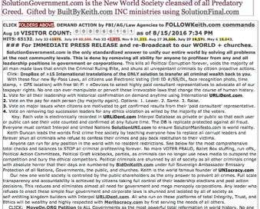
Help The Needy By Faith HNTBF.org CEO Emmanuel Jongo +(232)7639-0392, USA (443)741-5737 EJJongo@gmail.com
EbayIncomeSeller@Gmail.com
#2 Septimus Vandy Street Fonikor Kenema, Eastern Region, Sierra Leone, West Africa


USA gov owes me well over $500 Million USD for what criminals did to KeithBrentDUNCAN.org starting Jan 14, 2008 by ONLY Robert Dee Rose.

page 4 of 8
BBK20160826-13PlaguesRevelations-SolutionManifesto-393 Friday, August 26, 2016
https://www.facebook.com/keith.duncan.9231/posts/1768078256792959
describes the TRUE state of why the bucking Broncos are the CRIMINAL Corrupt Politicians who refuse to be herded and broken. Read for details and DEMAND ACTION using SolutionGovernment.com as your own BANNER AD. Ask everyone to JOIN UNITYurl.com also to create their own self-sustained communities of action. FatherKeith.com
Facebook reply from : Agustin Vasquez Jr Great luck, keep pushing if it's meant to be. The only thing, I don't like about electronic voting is the face recognition portion of it. It removes more of the animosity portion of your vote.
Keith’s immediate reply: So Simple. By taking your own photo WHEN you vote is for YOUR protection so you can go BACK and see each of your votes tied to your own Photo, Timestamp, and GPS location. NO one can see your votes UNLESS you turn on the public versus private switch. I would always vote PUBLIC view so anyone could see my voting history. This is READ ONLY to world. If the prime database is HACKED or changed, I would be notified it was CHANGED, Plus I could confirm each and every one of my votes. The ANOMINITY portion is exactly what the criminals use to CHANGE your votes by CHANGING the tallies. The PRIME part of FACE recognition is immediately knowing WHO IS the person you are dealing with. It allows all citizens to IDENTIFY criminals, terrorists, fraudsters, corrupt politicians, and anyone REGARDLESS of the money or clothes they flash. For FLASHING cash and power is used to buy almost anyone off.... This is the Corruption FREE zone that will soon be WORLDWIDE, with the help of all of humanity. This is the most powerful, broad reform movement, no disrespect with the word Broad, as all women must be protected first along with all children since man has always been the prime aggressor.
#### World Press Conferences and re-broadcast. Monday, Aug 22, 2016
The following is world broadcast commentary on USA Dept of State Press Release.
World Commentary is from Keith Duncan, the #1 Broadcast Journalist Evangelist Crusader who has already provided all the basic solutions to teach mankind how to REMOVE all terrorists, drug dealers, political criminals, cyber criminals, scam artists, and all other underground criminal enterprise operators.
Everyone who reads this ONE world broadcast, TAKE ACTION by understanding the realities of Political Corruption that is the root evil of all of mankind. Once removed from leadership positions, other criminals quickly are shunned and isolated since they no longer have anyone hidden in elected, appointed, and promoted positions to actively prevent the required investigations, arrests, and convictions. The most obscene sequence of legal proceedings is required to bring any guilty party to justice as detailed on the next few pages from FatherKeith.com Duncan Cell Philippines +(63)0917-335-4300 who will soon emerge as the most famous broadcast journalist Evangelist Crusader of all modern times as soon as you, my people RISE UP and TAKE ACTION as I have taught all of you.
#####!
Public Diplomacy and Public Affairs: Statement to the Press in Astana, Kazakhstan
08/17/2016
You are subscribed to Public Diplomacy for U.S. Department of State. This information has recently been updated, and is now available. Public Diplomacy and Public Affairs: Statement to the Press in Astana, Kazakhstan
08/17/2016 01:16 PM EDT
Statement to the Press in Astana, Kazakhsta

page 5 of 8
BBK20160826-13PlaguesRevelations-SolutionManifesto-393 Friday, August 26, 2016
Remarks by Sarah Sewall
Under Secretary for Civilian Security, Democracy, and Human Rights under USA Secretary of State John Kerry, from Astana, Kazakhstan
August 17, 2016
Before I take your questions, I’d like to briefly explain why I’ve come to Kazakhstan and share a few observations from my meetings this week.!
As you may know, two weeks ago Secretary Kerry hosted the so-called “C5+1” meeting between the five Central Asian republics and the United States to reinforce regional cooperation on a broad range of issues, including economic connectivity, the environment and climate change, human rights, and security.
My trip this week has a narrower focus: strengthening our cooperation against terrorism. Kazakhstan has played a leadership role in building global support for a broader preventive approach to violent extremism, including by hosting a summit here in Astana last June.
Two weeks ago in Washington, we announced U.S. support for the Global Counterterrorism Forum to hold a dialogue focused on countering radicalization to violence and the movement of foreign terrorist fighters across Central Asia.!
This week I'm here as the top counterterrorism official at the U.S. Department of State to learn about Kazakhstan's efforts to counter violent extremism. I've been impressed by the thoughtfulness and commitment of our Kazakhstani colleagues to address this problem. In meetings this week, I shared our observations about the factors often linked with terrorist radicalization – and more importantly – what we can do to prevent it.
One factor is often government behavior. Corruption, impunity, and poor public services can erode trust between people and government and create openings for violent extremist to recruit. Prisons that mix petty criminals with violent ideologues can provide terrorists a captive audience. And we’ve seen how governments that respond to terrorist attacks with torture, abuse, and restrictions on fundamental rights can actually fan terrorist radicalization by leading otherwise peaceful individuals to see violence as their only recourse.
That’s why, when Secretary Kerry visited Astana last November, he emphasized that “terrorist presence does not give authorities license to use violence indiscriminately... [or] to lock up political opponents.” In meetings this week, I’ve underscored that governments should take a “no harm” approach by ending counterproductive practices, fighting corruption at all levels, and respecting human rights.


page 6 of 8
BBK20160826-13PlaguesRevelations-SolutionManifesto-393 Friday, August 26, 2016
Sources of terrorist radicalization can also include personal or community alienation, hopelessness about the future, or hunger for identity and purpose. But addressing these vulnerabilities is not something governments alone can do; an effective approach must involve local communities. Religious leaders, researchers, teachers, women, and youth are often best positioned to intervene when vulnerable individuals are on the brink of violence. Similarly, free and independent media and citizen groups can refute terrorist ideologies and their false propaganda with far more credibility than government officials and outlets.
The U.S. welcomes Kazakhstan’s commitment to a broader and more preventive approach to terrorism, and we stand ready to work with partners in and out of government who will join us to turn back this shared threat.
Now let me take your questions….
The Office of Website Management, Bureau of Public Affairs, manages this site as a portal for information from the U.S. State Department.
External links to other Internet sites should not be construed as an endorsement of the views or privacy policies contained therein.

#### From FatherKeith.com Duncan Aug 22, 2016.
An absolute root world problem has always been the lack of standards to ensure evil persons do not overtake and overthrow the society and government institutes that were originally designed to ensure peace and tranquility throughout all lands. This includes the foundations of democracy, communism, socialism, monarchy, and others that served the people equally in their alpha beginnings. UNIocracy.com is the ONLY form of society government that incorporates the best of all human relations to ensure full scale accountability and integrity with one degree of separation between all my +7.44 billion people. This occurs using shared off shelf technology of mobile eDevice communications that ensures no one can commit hidden crimes and prevent their own punishment by extorting others with their stolen assets and abilities to deceive and divert attention away from their crimes using false witness and coercion techniques.
Cultural wars between differential factors of society have always been used to enrich the Criminal Ruling Elite who use every ways and means to capitalize and enslave their own people for their own nefarious means. The Press Release by Sarah Sewall identifies many of the prime world problems and international conflicts that exist because most people can not agree on unification of our entire world. The Solutions provided and taught our entire world are actually quite simple as they are based on the problem solving engine mechanics of 5 simple steps of http://www.SolutionFinal.com that has yet to be world re-broadcast because of the evil influx of capitalistic marketing and propaganda flood by advertisers who want everyone to be brain-washed consumer bureaucratic ‘sheeplets’ and piglets lead to slaughter by the industrialists, technologists, and capitalists who have obtain kingdoms by abusing each and every one of your civil, financial, legal, economic, sexual, and spiritual rights to be FREE PERSONS of the utmost integrity.
! This broadcast is very unique in its brevity and because I have not including the collective years of Acts of Wisdom that are the basis for how to transform your world into the Paradise of heaven as it is here on Earth. These are seen in the ‘book of life’ at http://www.IseeIunderstand.com and are cross referenced in database lookup manners on http://www.BuiltByKeith.com.
http://www.SolutionGovernment.com is the ONLY solution to truly rid our world of the serpent and satanic evil forces that are rapidly focusing on de-populating our world to ensure the survival and prosperity of the Criminal Ruling Elite. The standards of decency and righteousness are easy to obtain when our mutual world of uneducated persons UNIFY within the one spirit of our Creator’s original design for all of humanity.
By "Acting with the Authority of Fearless People to Protect All Rights of Others”, humanity quickly removes the con-artists and terrorist criminals using the forensic procedures I have documented to the nth laser focused degree using INTERPOL Gifted URLiDent.com This is the end times final results of my past +40 professional years designing perfect computer operational systems in the telecommunication, banking,
page 7 of 8

BBK20160826-13PlaguesRevelations-SolutionManifesto-393 Friday, August 26, 2016
cyber security, cutting edge / state of the art technology bonanza. These methodologies have broken through the extreme barricades and iron walls erected by most of the corrupt politicians in cabal league with criminals known as mega wealthy political donors, crime invested and serpent infested corporate executives, and underground crime enterprises run by the cruelest sociopath manias like Robert Dee Rose identified for 8 years on websites of WhereIsRobertRose.com and personally delivered to every single Law Enforcement Agency known to man. This includes Congress, United Nations, the USA (and other) Military, the Associated Press News broadcasters, and well over 200 churches in just the past 8 biblical years of extreme ‘HELL’ tribulation.
The true reasons for the ultimate trials and tribulations of the cause and effect of our human psychology conditions is caused by pure adulterated and prostituted greed. For the BIGOTS, hypocrites, cynics, blinded fools, criminal brood of viper serpents, and the un-educated masses are the complete ‘VENN’ diagram.

The extreme sequence of felony and capital crimes !
#####
This is the most recent Freedom of Information Request contents for world to see. The original emergency request and matching APPEAL were denied almost the same day they were submitted on 06/24/2016 and closed Aug 8, 2016 by Davita Brown with criminal excuse of: DOJ-AP-2016-003823 has been processed with the following final disposition: Closed for other reasons --
Other -- Improper Appeal
Expedited Disposition Reason: Your request for expedited handling of your appeal is denied. You have not provided a statement certified to be true and correct, nor have you explained which of the four expedited processing standards set forth in the Department of Justice regulations would apply to your appeal. See 28 C.F.R. 16.5(e)(3). Your appeal is currently being processed and this Office will respond to you once a final determination has been made on your appeal.
NEW Aug 20, 2016 DOJ-2016-004873 FoiaOnLine.Regulations.gov.
Again, emergency request for AG Loretta Lynch to investigate massive corruption tied to Norfolk VA 4:11cr112 destruction of Public Documents used to criminally hold Keith Duncan based on Cobb County GA TPO 11.1.1171.99 dated July 15, 2011 that shows NO violation could have occurred Sept 25, 2011 at Langley AFB VA. Release ALL sealed documents TO the FBI James Comey Corruption and Terrorism investigation teams to CONTACT FatherKeith.com using BidOnKeith.com so I can finally RETURN to testify with Press Conferences to our entire world. I have my USPressAssociation.org credentials and DEMAND-ORDER every criminal accuser be put on TRIAL for their direct ties to OneOceanBahamas.com Robert Dee Rose (DOB 1971-April-01) who personally owes $250,000 USD Forsyth County GA Judgment08SC-1345 and $8 Million from IRS WBFeb2009-658 Nora.Beardsley@IRS.gov. No criminal will go unpunished once NEWS MEDIA, with your help, is engaged to SHOW the TheTruthVault.com evidence already delivered for years to IRS, FBI, AG, USMarshals Military, and Congress.

CLOSING these emergency requests will clearly be PUBLISHED to world as the last example of political corruption since no one has ever actually UPHELD U.S.C. statutes of Law that are the true basis for this emergency request for ACTION. Clearly YOU know WHO to contact including COMEY and LYNCH. Ask the MILITARY to investigate as well as CONGRESS, since NO honest person of integrity has yet been identified despite years of direct requests and turn over all ALL Kshama.me criminal evidence with signatures. Interpol gifted URLiDent.com removes ALL political Criminals with SolutionGovernment.com that overthrows and replaces all corrupt governments worldwide. WHY has no one in authority EVER represented any of the Constitutional Rights of the one man who teaches our world HOW TO remove the criminals at almost ZERO taxpayer expense. This is the SEIZURE of the criminals own assets like Robert Dee Rose of TheFinalTerrorist.com.
END page 8 of 8

BACK to world famous PUBLIC SCANDAL DUNCANCLAIM.org minor excerpt.
DuncanCLAIM.org FortuneONE.org Keith Brent Duncan 2023 April 29. +1 770-377-2106.
Most obvious evidence of civil criminal felony crimes committed by named criminal and civil defendants at DuncanCLAIM.org 22-1-3042-68 filed May 3, 2022 universally was THEIR signed court document submitted evidence at all levels starting back with Forsyth County Judgment 08Sc-1345 Keith Brent Duncan versus Robert DEE ROSE (international Cyber Crime terrorist cabal groups of HomeWaves.com and OneOceanBahamas.com) from year 1995 forward per ROSEs testimony this entire time focusing on Cobb County TPO 11.1.7683 and 11.1.1171 successful attempts by all involved to persecute, illegally detain kidnap, and brutally assault and rob YOU, my most beloved +8 Billion WE GODS PEOPLE, of being free will sovereign citizens at all levels forever. Always 100% most simple use of KISS 5Steps.life that Keith and GOD used to generate Perfected omnipresent EVOTE.ONE FOIA.ONE ReInvestall.com and now +155 website perfected video based solutions that self teach educate inform and motivate EACH of YOU to deal with any local internal emotional issue, then directly address your family, community, church, political, and regional problems by actually SOLVING the conflict and infrastructure situations by providing all required resources of our time and assets and skills to prevent then reverse any further occurrences. THEN share gifting these same solutions to everyone else through now KeithDuncanLibrary.org (*.com) we procreated 2023April28 on our van trip to Daytona Beach Florida with our fellow FortuneONE.org and CEOSPACE.NET #1 top world leaders of Gabriel, Nicu, and Jeff.
Simple GOOGLE of ‘Keith Brent Duncan’ has the following most profound GODs search resources at the very top.
####
https://casetext.com/case/united-states-v-duncan-63
Criminal Action No. 4:11cr112.
ISSUED 2013-07-22.
SIDE BAR NOTE: KeithDuncan.org was accidentally released Jan 28, 2014 as being 100% un-convictable as Judge Jackson and all others criminally sealed all documents on Jan 28, 2014 when Keith and all others saw EVERYTHING had been criminally stolen and sold off by murdered Brian Walker and Duncan Clan of very ex-wife Sherry Duncan, two sons Matthew Vernon Duncan, and Kyle Smith Duncan. All using forged outdated never valid Power Of Attorneys.
HERE is the exact Court Order verbiage also sealed so NO ONE would ever investigate convict ANYONE.
UNITED STATES of America, v. Keith Brent DUNCAN, Defendant.
Id. The Supreme Court has made clear that the circumstances justifying the intrusion of the liberty of an individual person implicit in the act of formability FORCE medicating a criminal defendant are “rare.” Id. United States v. Bush, 585 F.3d 806, 814 (4th Cir.2009) (internal citation omitted). Therefore, the Court must find that the Sell Factors weigh in favor of the Government by clear and convincing evidence. Id.
Federal Judge RAYMOND A. JACKSON, Norfolk VA
Robert Edward Bradenham, II, United States Attorney's Office, Newport News, VA, for United States of America.
MEMORANDUM OPINION AND ORDER
, District Judge.
Before the Court is the Motion for Authorization to Administer Involuntary Medication to Defendant Keith Brent Duncan (“Defendant”) to restore his competence to stand trial. Having reviewed parties' memoranda and heard oral arguments and testimony on the motion, this matter is now ripe for judicial disposition.
I. PROCEDURAL AND FACTUAL BACKGROUND
On December 13, 2011, an Eastern District of Virginia Grand Jury filed a Criminal Indictment against Defendant, charging him with Unlawful Possession of a Firearm, in violation of 18 U.S.C. § 922(g)(8).
Defendant is also subject to forfeiture of the Springfield 16 gauge double barrel shotgun (and related ammunition) at issue in the Indictment. The Defendant was arrested on February 22, 2012, and has been the custody of the United States since that date. On March 19, 2012, a United States Magistrate Judge ordered that the Defendant undergo examination to determine whether he may be suffering from a mental disease or defect under Rule 12.2 of the Federal Rules of Criminal Procedure and Title 18, United States Code, Sections 4241(a) and (b).
United States v. Duncan, 968 F. Supp. 2d 753, (E.D. Va. 2013)

…ETC…. ### end of todays most irrefutable also KEY evidence of WHY GOD sent KEITH Brent Duncan alone to be almost murdered, robbed, persecuted, and denied all YOUR rights forever. ###
NOTE Pages. Few if anyone EVERY takes notes, much less TAKES real time ACTION to unify mankind using GODs original 5STEPS.life.
GodsCrusade.org FortuneONE.org CreatorKeith.com
PeaceSummit2020@gmail.com OneNews.Foundation
+1 770 377-2106 Atlanta GA, Asheville NC. USA
InvestmentONE.org OneBank.foundation
UNIocracy.ORG Evote.one FOIA.one Unifier forever.
ReInvestALL.com GODs crime free New World
Commands We host Press Conferences NOW!
SolutionMilitary.com TurnOffLights.com
WorldSchoolFund.org TeenMM.com beSmartBeRICH.com
Keith DuncanCLAIM.org !!! +$500 Million USD lawsuit.

Everyone CROSS promote mass publicity REINVESTALL.com and world changing original 100% direct eDemocracy voting of EVOTE.ONE. YOU WILL BE FUNDED, PAID to help eliminate ALL those who cause All world mass poverty and All Wars USING these simple ancient GODs 5steps.life generator. BidOnKeith.com Keith Duncan +1 770-377-2106 CALL us ONLY if you are 100% honest GOD loving. Fast Path deploy 5STEPS.life of PeaceSUMMIT2020.com + SolutionLawENFORCEment.com FOIA.ONE

CreatorKeith.com World UNIOCRACY.ORG ANSWERS FOR HUMANITY
PeaceSummit2020.com Each Sunday Host ProphetKeith.com +1 770-377-2106

All world Presidents + top Elite Corp Executives Commanded to attend Town Forums.
1. We solve all base world problems 5Steps.life as Public Servants of We Gods People.
2. FOIA.one IID Who is Who, Who owns What. Share all evidence of who are top violators to Judge.
3. Assign SolutionMilitary.com to find terrorists Open Public Investigations.
4. Agree to redistribute crime wealth to 3rd world nations in greatest need using Evote.One CreatorKeith.com 1% seized and crowdfunds of +8Billion WE Gods People of DisciplesOfKeith.org
5. Agree to transfer millions of our young adults to places of greatest needs with WorldSchoolFund.Org 100% free Foreign Exchange Student Keith's Program TeamMoneyMachine.org
6. Agree to remove all by-laws and regulations that prohibit the immediate deploy of ProfitShareHolders.com from being our new world free trade total barter society.
7. Agree to eliminate all corporate corrupt criminal violators of human rights individuals using Will of Free Citizens use of GodsConstitution.org use of SolutionJudge.com by EVOTE.ONE.
8. Agree to universal FOIA.one IID and eliminate purge DOJ DOD Corporate Executives who violate laws SolutionLawEnforcement.com + SolutionManifesto.com
9. Protect the lives + Assets of SaintKeith.com keith2022.com + those of highest IQ merit.

Protect All Presidential, Leaders, Corporate Executives Work for GODS people. Reset from Sept 2011. WhereIsRobertRose.com and DUNCANClaim.org
Each of these are CLIENT3635.wix.com/* world self saving solutions.
### April 13, 2023 Total of 155 GODs world reform new world systems (ordered).
5Steps.LIFE. Basic GODs generator procreates all method solutions and life.
Aug 30, 2023 by most humble Keith Brent Duncan. sent by GOD IID 1-19580815-1 Integrity +100%) +1 770-377-2106, +1 725-200-7683.
ISBN: 9798392441563

§ § § § § §
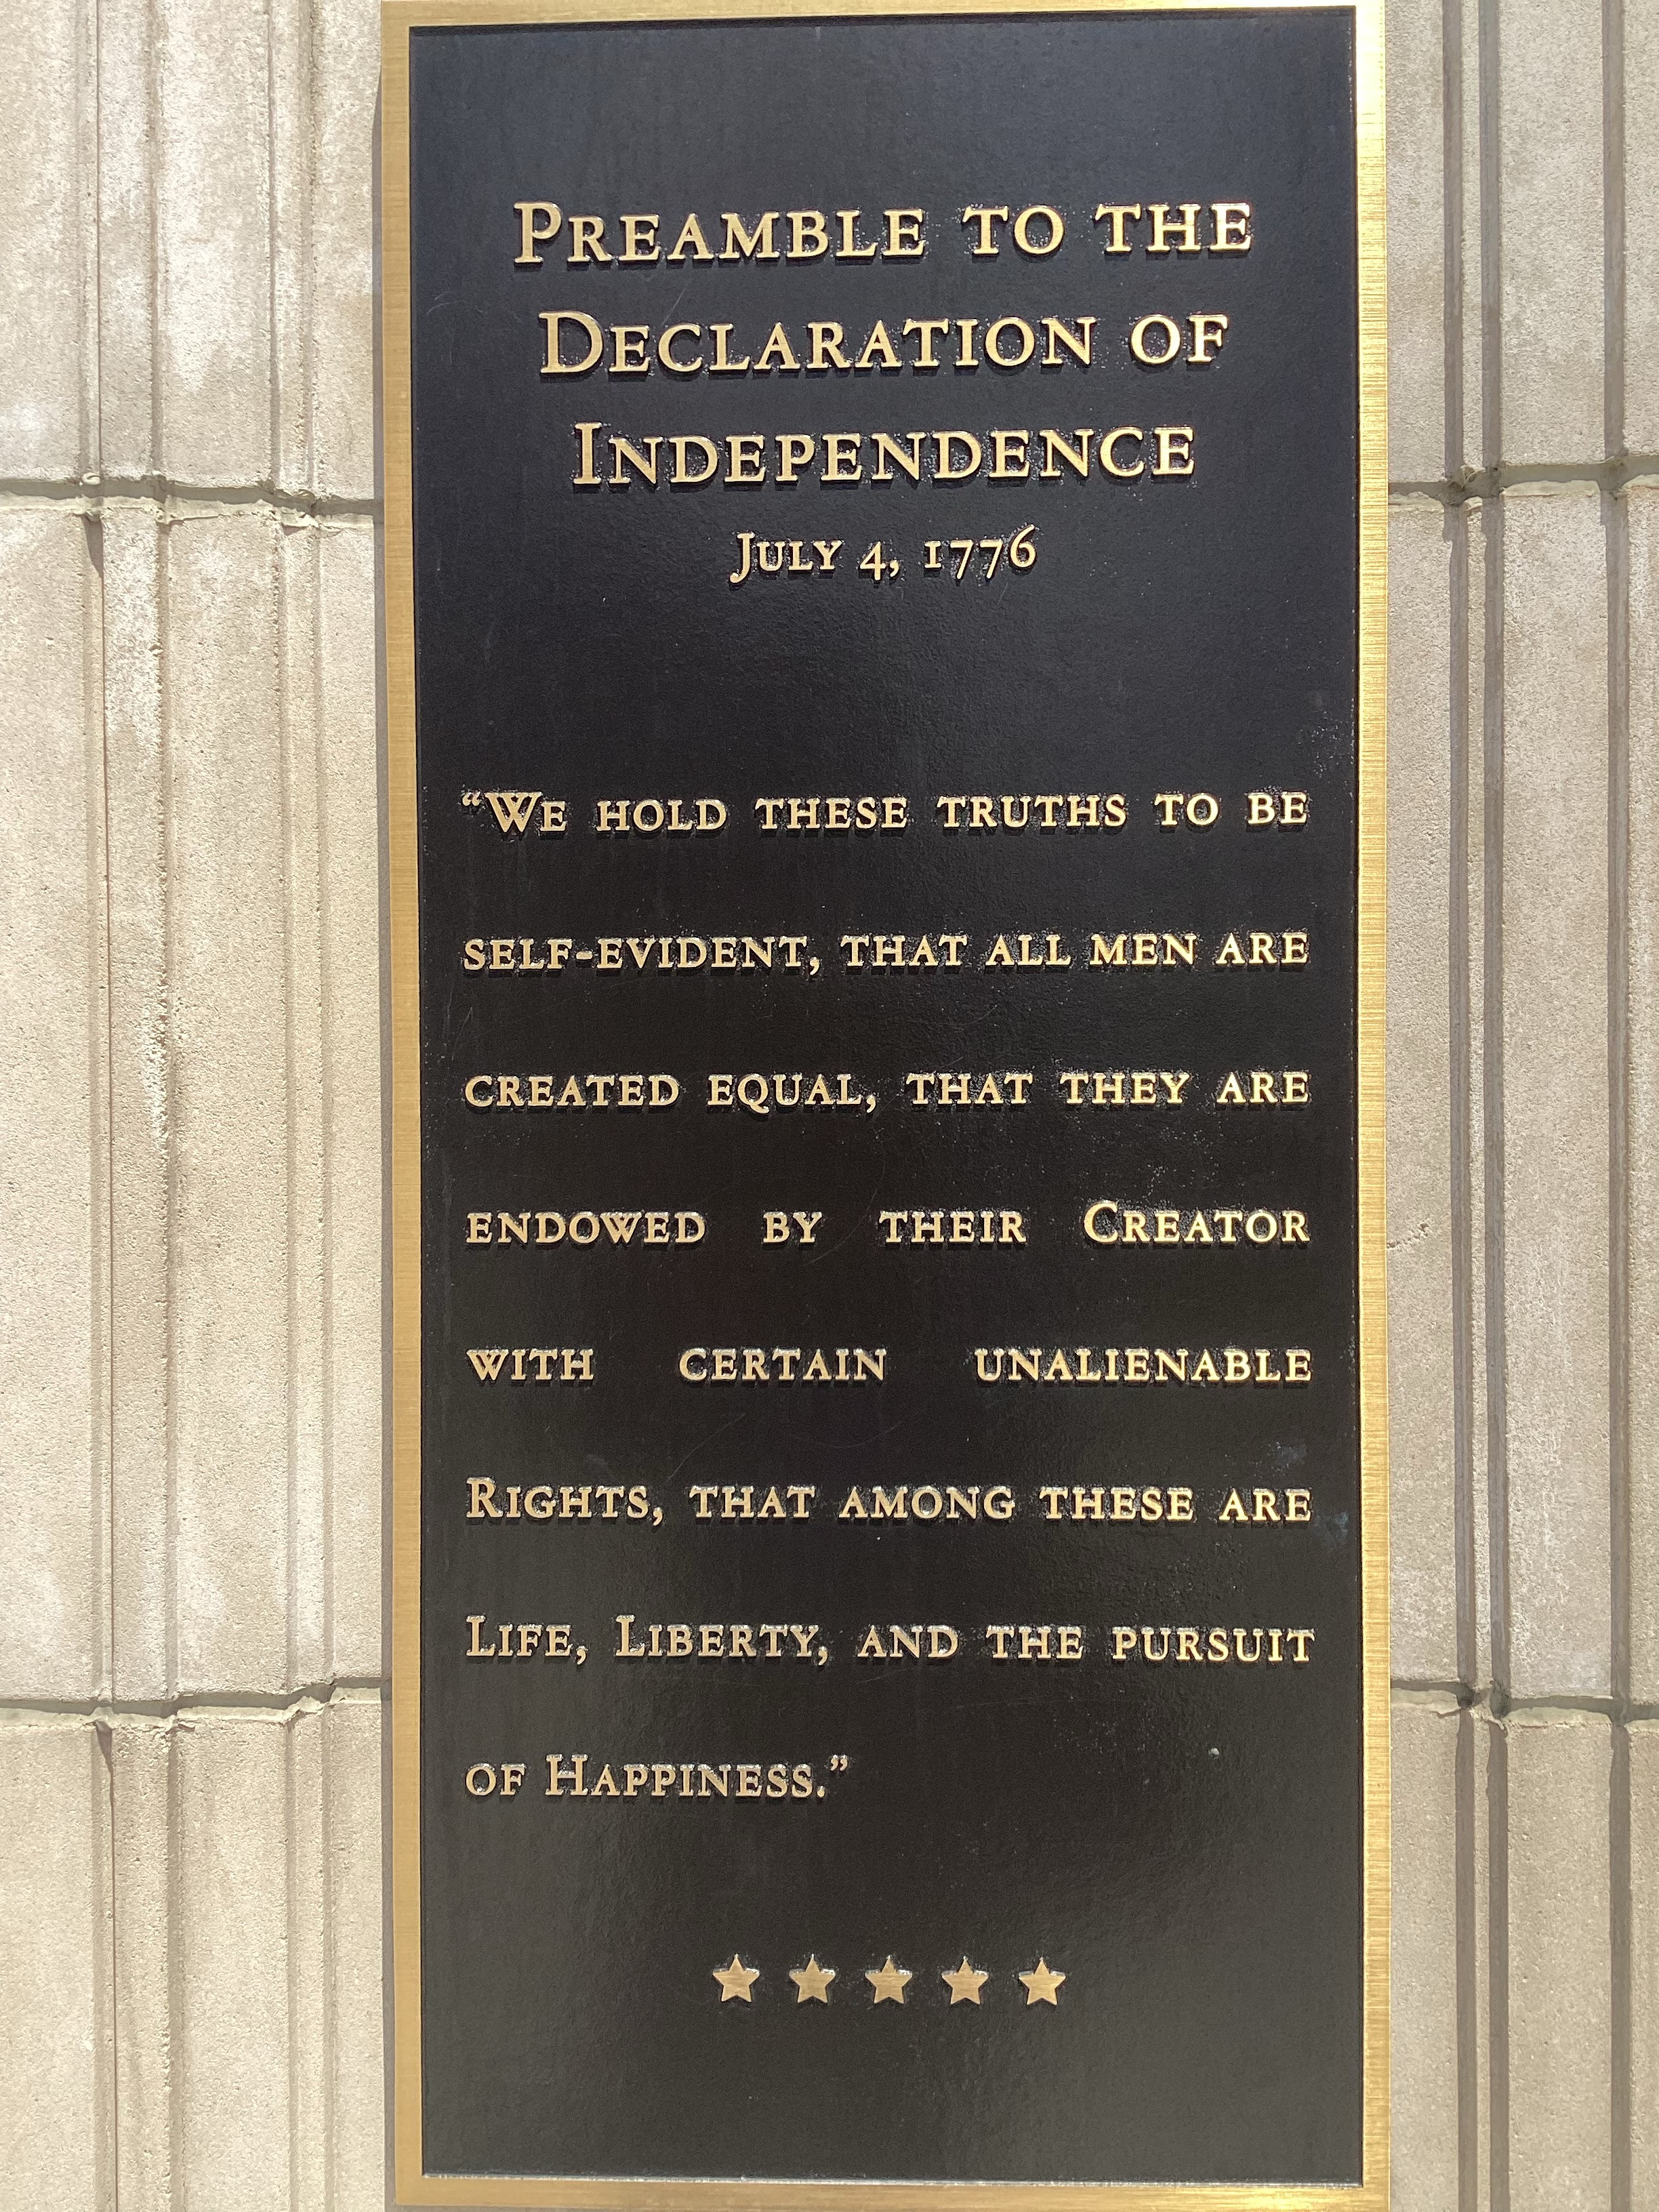
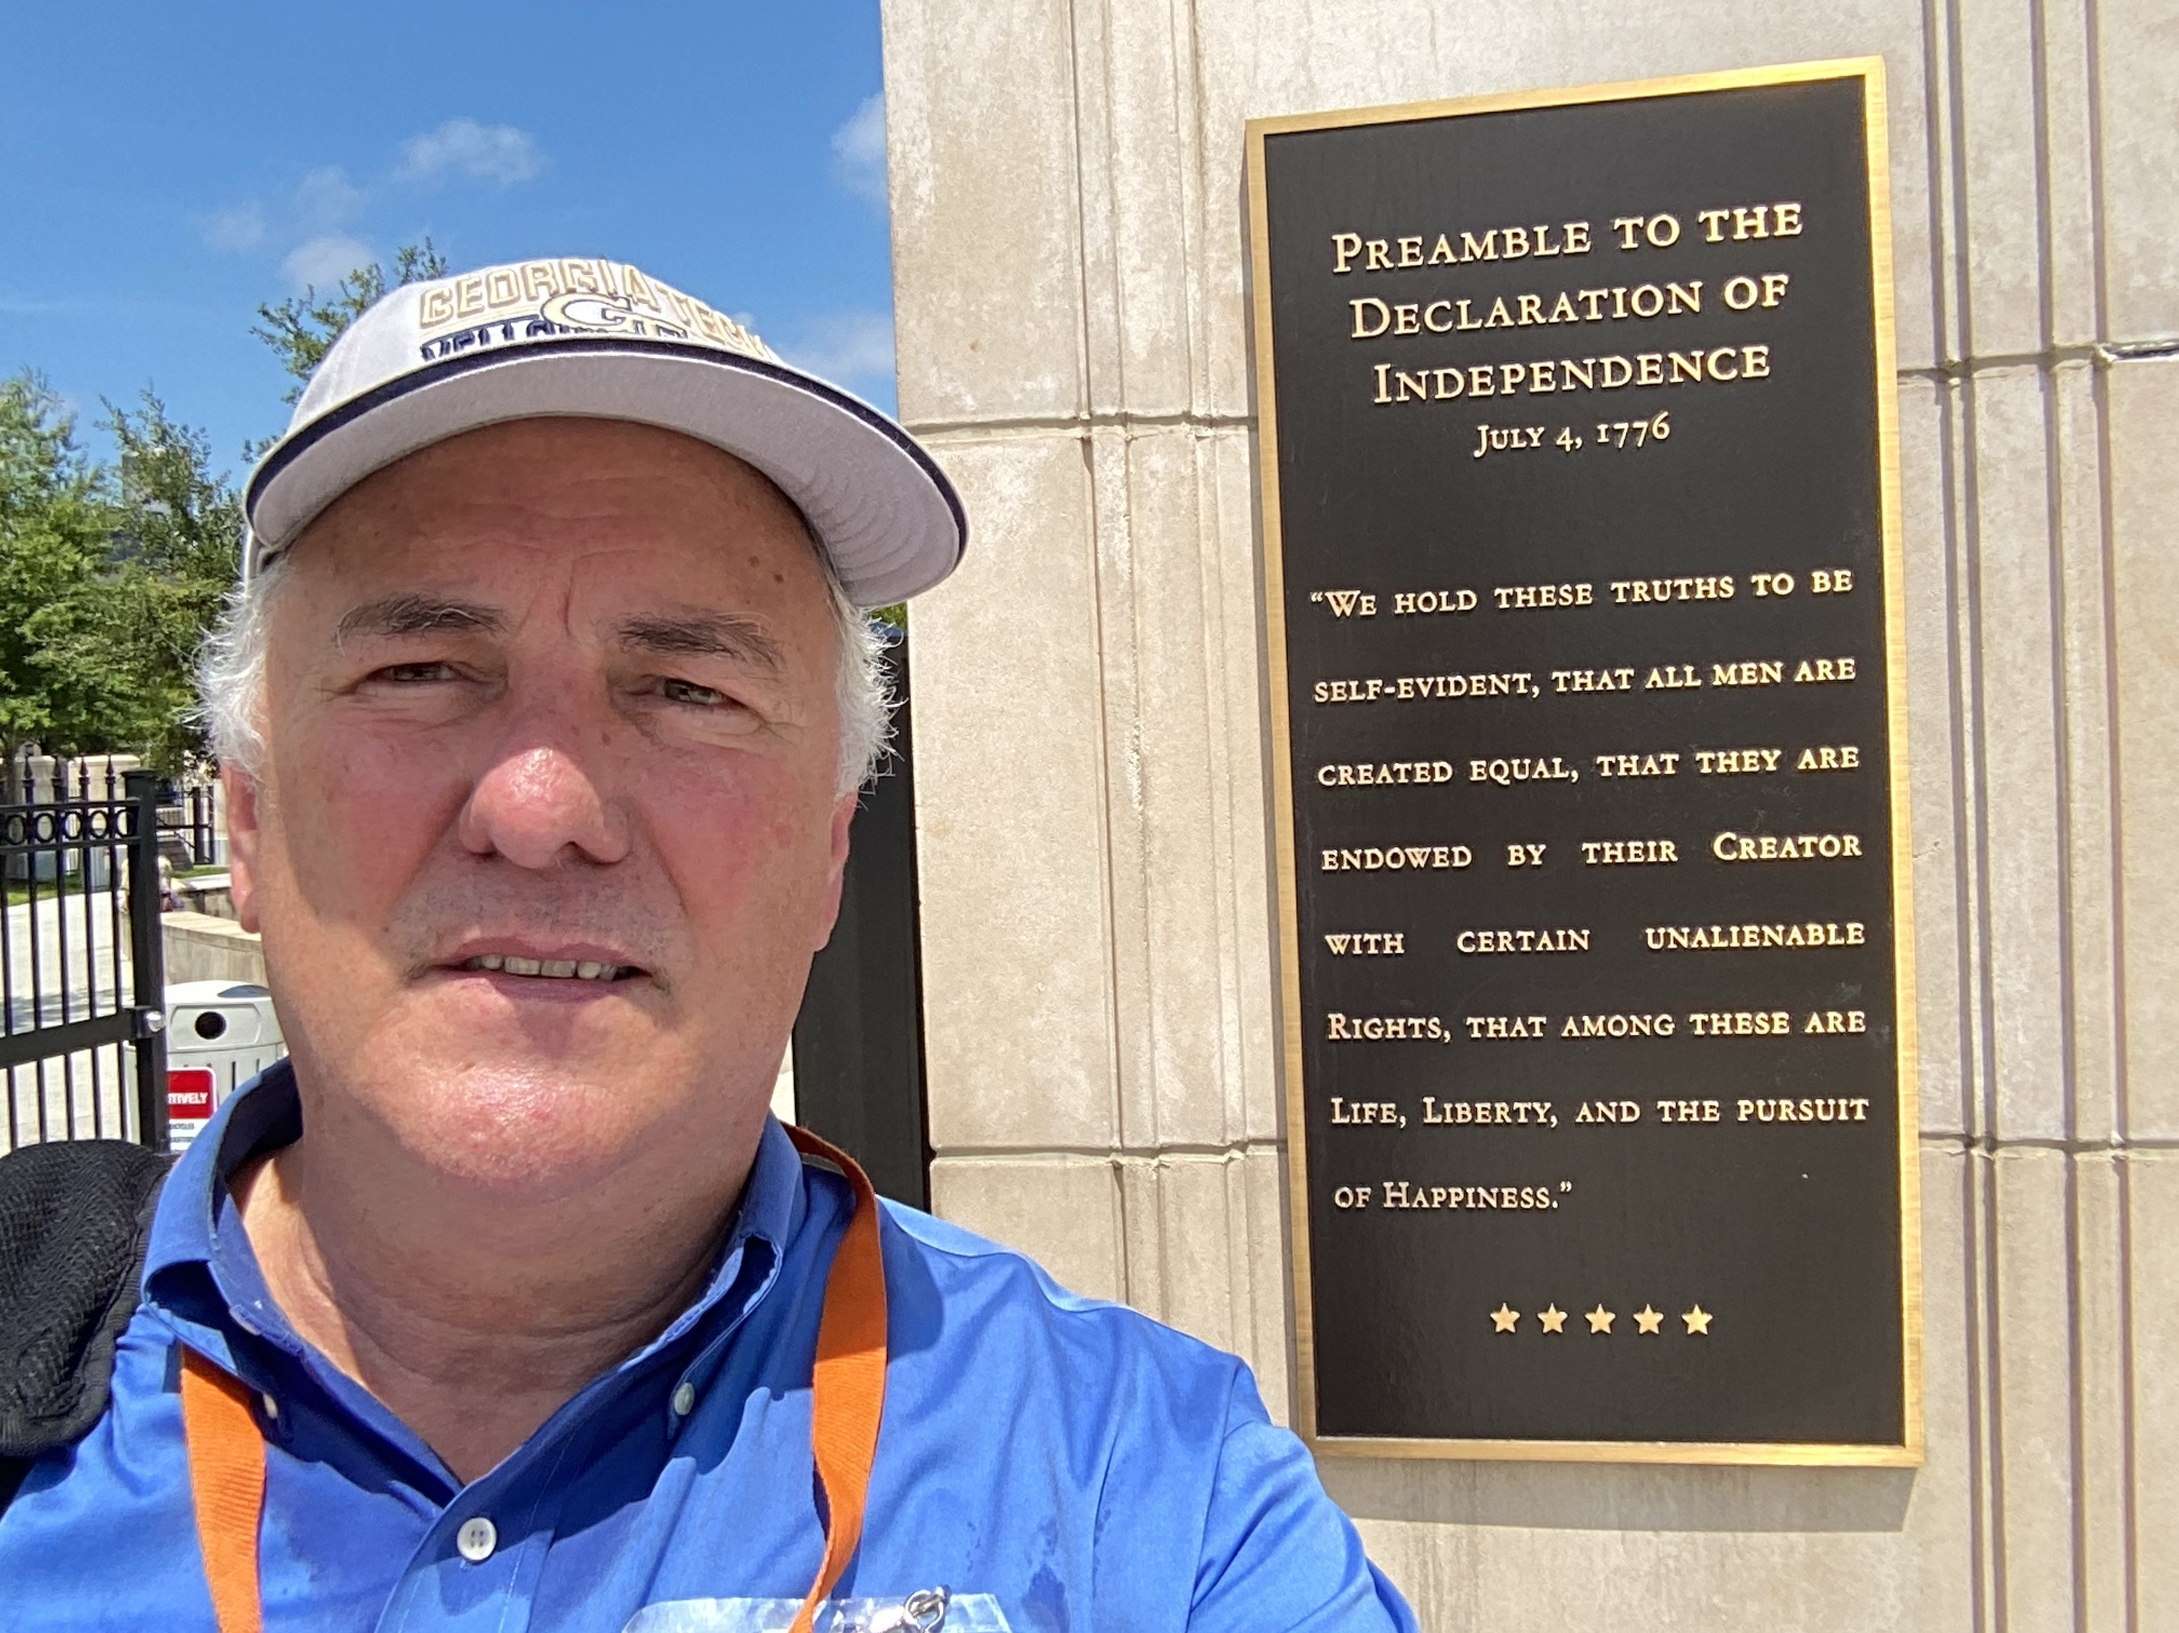
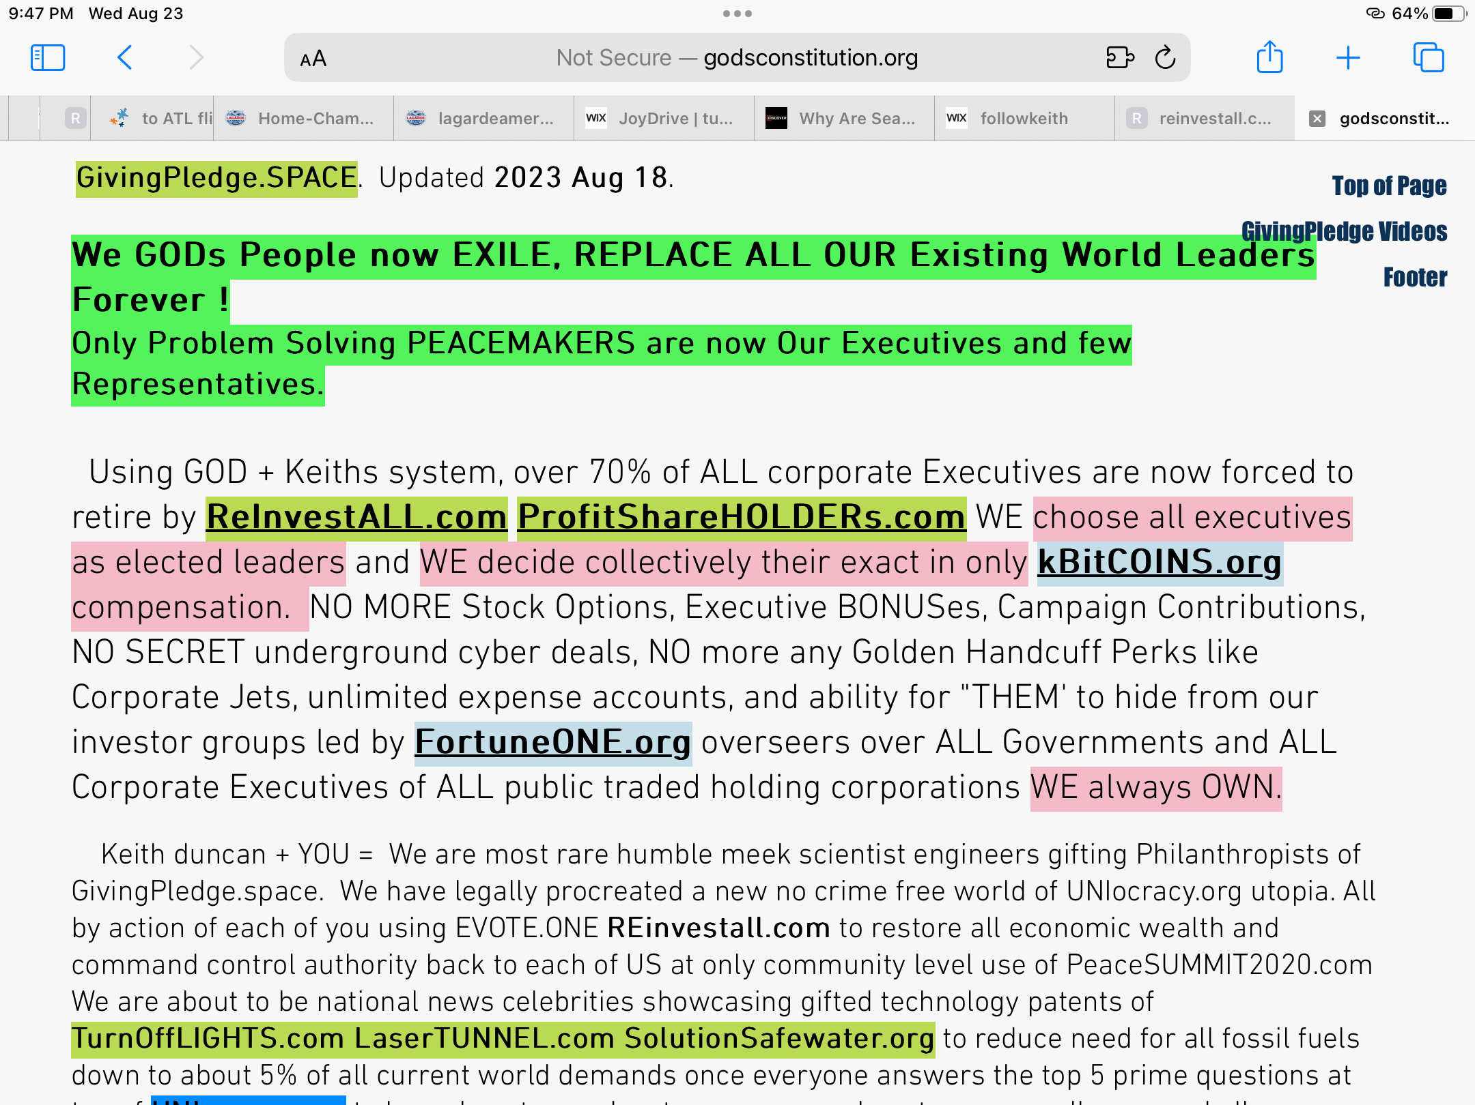
File: 1195-VeryLast-SolutionManifesto-Constitution-2023Aug30 FortuneONEorg-v108

